Line Graphs
Name : | Class : | Date :

Mark : | /4 | %

1) The line graph below shows the number of times Rhys used his car over 7 days.  a) How many times did Rhys drive his car on day 7?  b) On which day did he use his car 5 times? | [1]
2) The line graph below shows the hourly temperatures on one day in February.  a) What was the temperature at 6 pm?  b) At what time was the lowest temperature recorded?  c) At what time was the highest temperature recorded?  d) What was the difference in temperature between 3 and 8 pm? | [1]
3) The table shows the number of times Jackson used his van each day of the week.  Draw a line graph using the grid below to represent this data.  Day Frequency  1 1  2 4  3 8  4 7  5 9  6 2  7 5 | [1]
4) The table below shows the distance Gabriel travelled by van each day of the week.  Draw a line graph using the grid below to represent this data.  Day Miles  1 32  2 48  3 16  4 35  5 44  6 10  7 47 | [1]
Solutions for the assessment Line Graphs
1) a) 4, b) 6 | 2) a) 7ºC, b) 10 pm, c) 4 pm, d) 4ºC
3) 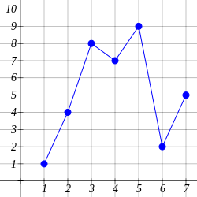

4) 