Line Graphs
Name : | Class : | Date :

Mark : | /4 | %

1) The line graph below shows the number of times Jayden used his car over 7 days.  a) How many times did Jayden drive his car on day 1?  b) On which day did he use his car 6 times? | [1]
2) The line graph below shows the hourly temperatures on one day in November.  a) What was the temperature at 4 pm?  b) At what time was the lowest temperature recorded?  c) At what time was the highest temperature recorded?  d) What was the difference in temperature between 5 and 7 pm? | [1]
3) The table shows the number of times Alex used his van each day of the week.  Draw a line graph using the grid below to represent this data.  Day Frequency  1 6  2 1  3 7  4 3  5 2  6 9  7 4 | [1]
4) The table below shows the distance Ben travelled by car each day of the week.  Draw a line graph using the grid below to represent this data.  Day Miles  1 46  2 37  3 14  4 47  5 32  6 19  7 36 | [1]
Solutions for the assessment Line Graphs
1) a) 7, b) 5 | 2) a) 9ºC, b) 10 pm, c) 4 pm, d) 2ºC
3) 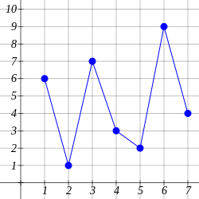

4) 