Line Graphs
Name : | Class : | Date :

Mark : | /4 | %

1) The line graph below shows the number of times Oscar used his van over 7 days.  a) How many times did Oscar drive his van on day 2?  b) On which day did he use his van 6 times? | [1]
2) The line graph below shows the hourly temperatures on one day in December.  a) What was the temperature at 8 pm?  b) At what time was the lowest temperature recorded?  c) At what time was the highest temperature recorded?  d) What was the difference in temperature between 3 and 7 pm? | [1]
3) The table shows the number of times Harry used his car each day of the week.  Draw a line graph using the grid below to represent this data.  Day Frequency  1 9  2 2  3 4  4 7  5 3  6 1  7 6 | [1]
4) The table below shows the distance Oliver travelled by car each day of the week.  Draw a line graph using the grid below to represent this data.  Day Miles  1 23  2 15  3 24  4 44  5 34  6 32  7 38 | [1]
Solutions for the assessment Line Graphs
1) a) 9, b) 4 | 2) a) 2ºC, b) 10 pm, c) 4 pm, d) 5ºC
3) 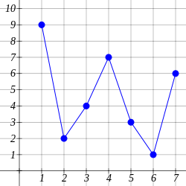

4) 