Bar Charts
Name : | Class : | Date :

Mark : | /10 | %

1) The bar chart shows the number of computers sold in a store during the first four days of this week.  How many computers did they sell on Tuesday? | [1]
2) The bar graph shows the number of board games a store sold in the last 4 days.  How many board games did they sell altogether? | [1]
3) A group of students were surveyed on their favourite type of movie. Use the bar chart to answer the questions below.  a) How many students prefer Western movies?  b) Which type of movie was preferred by 9 students?  c) Which is the most popular movie?  d) How many students were surveyed? | [1]
4) The bar graph shows the number of model cars a shop sold last week.  a) How many model cars were sold on Mon?  b) On which day were 12 model cars sold?  c) On which day were the most model cars sold?  d) How many model cars were sold altogether? | [1]
5) The bar graph shows the shoe sizes of a group of children.  a) How many children have shoe size 3?  b) Exactly 8 children have which shoe size?  c) Which is the most common shoe size?  d) How many children were surveyed altogether? | [1]
6) The bar graph below shows the percentage of students who received grades A-D on their last English paper. The class contains 60 students.  How many students received C on their paper? | [1]
7) The bar graph and table show the number of model cars a store sold during a five month period. Complete the bar graph.  Week Number of model cars  1 70  2 90  3 50  4 80  5 100 | [1]
8) The bar graph and table show the number of tennis rackets a store sold during a five month period. Complete the bar graph and frequency table.  Day Number of tennis rackets  1 40  2 100  3  4 80  5 | [1]
9) The incomplete bar graph below shows the number of tennis rackets a store sold over five weeks.  a) 50 tennis rackets were sold in the 1st week. Show this on the graph.  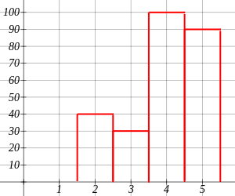  b) How many tennis rackets were sold in the 3rd week?  c) How many more tennis rackets were sold in the 4th week than the 2nd week? | [1]
10) The bar graph shows the number of bicycles a store sold last week. Fill in the table using the graph.  Day of the Week Frequency  Thursday  Friday  Saturday  Sunday | [1]
Solutions for the assessment Bar Charts
1) 3 | 2) 20
3) a) 4, b) Comedy, c) Thriller, d) 25 | 4) a) 10, b) Thu, c) Sat, d) 54
5) a) 24, b) 7, c) 6, d) 102 | 6) 6
7) 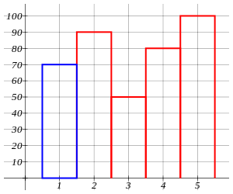

8) month 3 = 30, month 5 = 90
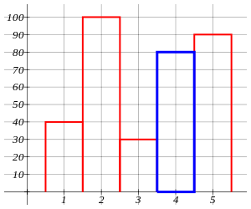

9) a)
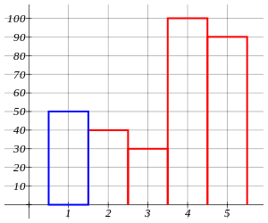
b) 30, c) 60

10) Thursday = 4, Friday = 5, Saturday = 10, Sunday = 3

