Area and Circumference of Circle
Name : | Class : | Date :

Mark : | /12 | %

1) Name the labelled parts of the circle below.  Choose from the following words: segment, sector, chord, circumference, centre, radius, diameter, arc  1.  2.  3.  4.  5.  6.  7.  8. | [1]
2) Estimate the area of the circle by counting unit squares  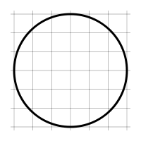 | [1]
3) Find the area of the circle pictured below, rounding your answer to 3 significant figures  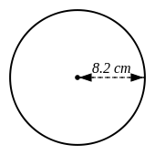 | [1]
4) Find the area of the circle pictured below, rounding your answer to 3 significant figures  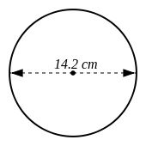 | [1]
5) The circumference of a circle is 8.1 cm. Find the area of the circle, rounding your answer to 3 significant figures. | [1]
6) The area of a circle is 3.4 $cm^{2}$. Find the circumference of the circle, rounding your answer to 3 significant figures. | [1]
7) Find the radius of a circle which has an area of 5.9 $cm^{2}$ | [1]
8) Find the diameter of a circle which has an area of 35 $cm^{2}$ | [1]
9) Find the circumference of the circle pictured below, rounding your answer to 3 significant figures  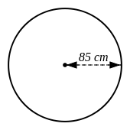 | [1]
10) Find the circumference of the circle pictured below, rounding your answer to 3 significant figures  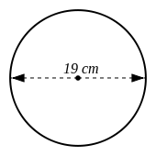 | [1]
11) Find the radius of a circle, where the circumference is:  8.5 cm | [1]
12) Find the diameter of a circle, where the circumference is:  3.6 cm | [1]
Solutions for the assessment Area and Circumference of Circle
1) 1 = diameter, 2 = circumference, 3 = chord, 4 = sector  5 = segment, 6 = arc, 7 = centre, 8 = radius | 2) Area = 28 $cm^{2}$
3) Area = 211 $cm^{2}$ | 4) Area = 158 $cm^{2}$
5) Area = 5.22 $cm^{2}$ | 6) Circumference = 6.54 cm
7) Radius = 1.37 cm | 8) Diameter = 6.68 cm
9) Circumference = 534 cm | 10) Circumference = 59.7 cm
11) Radius = 1.35 cm | 12) Diameter = 1.15 cm

