Area and Circumference of Circle
Name : | Class : | Date :

Mark : | /12 | %

1) Name the labelled parts of the circle below.  Choose from the following words: segment, sector, chord, circumference, centre, radius, diameter, arc  1.  2.  3.  4.  5.  6.  7.  8. | [1]
2) Estimate the area of the circle by counting unit squares  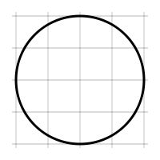 | [1]
3) Find the area of the circle pictured below, rounding your answer to 3 significant figures  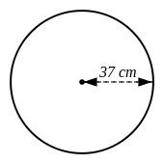 | [1]
4) Find the area of the circle pictured below, rounding your answer to 3 significant figures  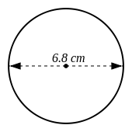 | [1]
5) The circumference of a circle is 4.9 cm. Find the area of the circle, rounding your answer to 3 significant figures. | [1]
6) The area of a circle is 2.6 $cm^{2}$. Find the circumference of the circle, rounding your answer to 3 significant figures. | [1]
7) Find the radius of a circle which has an area of 92 $cm^{2}$ | [1]
8) Find the diameter of a circle which has an area of 5.5 $cm^{2}$ | [1]
9) Find the circumference of the circle pictured below, rounding your answer to 3 significant figures  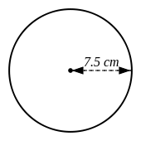 | [1]
10) Find the circumference of the circle pictured below, rounding your answer to 3 significant figures  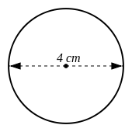 | [1]
11) Find the radius of a circle, where the circumference is:  13 cm | [1]
12) Find the diameter of a circle, where the circumference is:  8.8 cm | [1]
Solutions for the assessment Area and Circumference of Circle
1) 1 = centre, 2 = circumference, 3 = segment, 4 = chord  5 = diameter, 6 = radius, 7 = sector, 8 = arc | 2) Area = 13 $cm^{2}$
3) Area = 4300 $cm^{2}$ | 4) Area = 36.3 $cm^{2}$
5) Area = 1.91 $cm^{2}$ | 6) Circumference = 5.72 cm
7) Radius = 5.41 cm | 8) Diameter = 2.65 cm
9) Circumference = 47.1 cm | 10) Circumference = 12.6 cm
11) Radius = 2.07 cm | 12) Diameter = 2.80 cm

