Perimeter
Name : | Class : | Date :

Mark : | /7 | %

1) A square has sides of length 3 centimetres. Find its perimeter.  Perimeter = ......... cm | [1]
2) Find the perimeter of the rectangle.  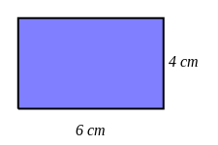 Perimeter = ......... cm | [1]
3) Find the perimeter of the shape. Each square on the grid is 1 cm by 1cm.  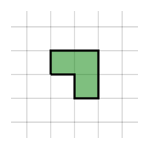 Perimeter = ......... cm | [1]
4) | [1]
5) The tile pattern below is made from 2 squares.  The edge of one square is 8 cm.  Calculate the total distance around the edge of the pattern. ......... cm   | [1]
6) The tile pattern below is made from 3 regular octagons.  The edge of one regular octagon is 8 cm.  Calculate the perimeter of the pattern. ......... cm   | [1]
7) The tile pattern below is made from 4 squares.  The edge of one square is 5 cm.  Calculate the perimeter of the pattern. ......... cm   | [1]
8) The tile pattern below is made from 4 regular octagons.  The perimeter of one regular octagon is 88 cm.  Calculate the distance around the edge of the pattern. ......... cm   | []
Solutions for the assessment Perimeter
1) 12 | 2) Perimeter = 20 cm
3) Perimeter = 8 cm | 4)
5) Perimeter = 48 cm | 6) Perimeter = 160 cm
7) Perimeter = 40 cm | 8) Distance = 264 cm

