Perimeter
Name : | Class : | Date :

Mark : | /7 | %

1) A square has sides of length 11 centimetres. Find its perimeter.  Perimeter = ......... cm | [1]
2) Find the perimeter of the rectangle.  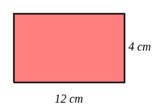 Perimeter = ......... cm | [1]
3) Find the perimeter of the shape. Each square on the grid is 1 cm by 1cm.  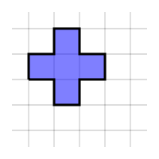 Perimeter = ......... cm | [1]
4) | [1]
5) The tile pattern below is made from 2 equilateral triangles.  The edge of one equilateral triangle is 4 cm.  Calculate the total distance around the edge of the pattern. ......... cm  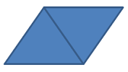 | [1]
6) The tile pattern below is made from 3 squares.  The edge of one square is 12 cm.  Calculate the perimeter of the pattern. ......... cm   | [1]
7) The tile pattern below is made from 4 squares.  The edge of one square is 6 cm.  Calculate the perimeter of the pattern. ......... cm   | [1]
8) The tile pattern below is made from 3 regular hexagons.  The perimeter of one regular hexagon is 42 cm.  Calculate the distance around the edge of the pattern. ......... cm   | []
Solutions for the assessment Perimeter
1) 44 | 2) Perimeter = 32 cm
3) Perimeter = 12 cm | 4)
5) Perimeter = 16 cm | 6) Perimeter = 96 cm
7) Perimeter = 48 cm | 8) Distance = 98 cm

