Ordering Negative Numbers
Name : | Class : | Date :

Mark : | /3 | %

1) Order the following temperatures from coldest to warmest  8 -8 2 -13  ......... ......... ......... .........  coldest warmest | [1]
2) Write these numbers in order on the number line:  5 -5 -2 1  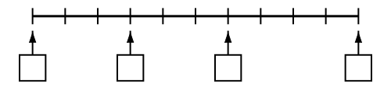 | [1]
3) Write in the missing numbers  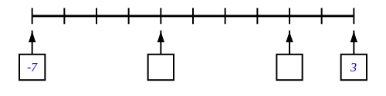 | [1]
Solutions for the assessment Ordering Negative Numbers
1) -13, -8, 2, 8 | 2) missing numbers are -5, -2, 1, 5
3) missing numbers are -3 and 1

