Ordering Negative Numbers
Name : | Class : | Date :

Mark : | /3 | %

1) Order the following temperatures from coldest to warmest  6 -7 -12 7  ......... ......... ......... .........  coldest warmest | [1]
2) Write these numbers in order on the number line:  5 -5 -1 3  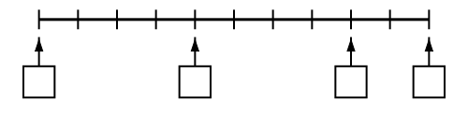 | [1]
3) Write in the missing numbers  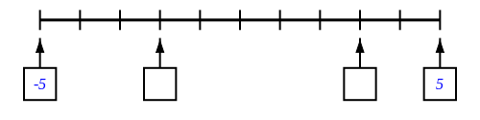 | [1]
Solutions for the assessment Ordering Negative Numbers
1) -12, -7, 6, 7 | 2) missing numbers are -5, -1, 3, 5
3) missing numbers are -2 and 3

