Ordering Negative Numbers
Name : | Class : | Date :

Mark : | /3 | %

1) Order the following temperatures from coldest to warmest  7 -17 1 -7  ......... ......... ......... .........  coldest warmest | [1]
2) Write these numbers in order on the number line:  6 -4 -1 2  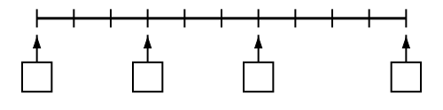 | [1]
3) Write in the missing numbers  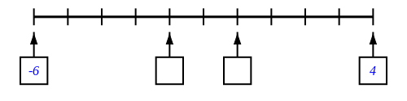 | [1]
Solutions for the assessment Ordering Negative Numbers
1) -17, -7, 1, 7 | 2) missing numbers are -4, -1, 2, 6
3) missing numbers are -2 and 0

