Place value and number facts
Name : | Class : | Date :

Mark : | /10 | %

1) Write down the digit that means tens in 82 ......... | [1]
2) Partition the numbers and complete the number sentences.  15 $=$ ....... $+$ ....... 96 $=$ ....... $+$ ....... | [1]
3) Write an ordered list of 2 digit numbers from the three numbers below.  3 6 7  36 ....... ....... ....... ....... 76  smallest largest | [1]
4) Write 47 in the correct place in the number square.  31 32 33 34 35  36 37 38 39 40 | [1]
5) Put these numbers in order of size, starting with the smallest number.  47 88 84 99 15  ...... ...... ...... ...... ......  smallest largest | [1]
6) Use $<$ or $>$ to make a true statement.  28 ...... 91 | [1]
7) Complete the number sentences using the number line.  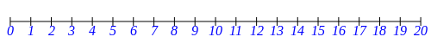  ......... is between 12 and 14  11 is between 10 and .........  5 is between ......... and 6 | [1]
8) Write in the missing numbers  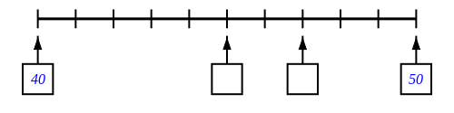 | [1]
9) Write in the missing numbers | [1]
10) How many small blocks are there altogether? ......... | [1]
Solutions for the assessment Place value and number facts
1) 8

2)
15 $=$ 10 $+$ 5 96 $=$ 90 $+$ 6

3) 37, 63, 67, 73 | 4) 46 47 48 49 50
5) 15 47 84 88 99 | 6) 28 < 91
7) 13, 12, 4 | 8) missing numbers are 45 and 47
9) missing numbers are 41 and 46 | 10) 44

