Place value and number facts
Name : | Class : | Date :

Mark : | /10 | %

1) Write down the digit that means tens in 25 ......... | [1]
2) Partition the numbers and complete the number sentences.  28 $=$ ....... $+$ ....... 73 $=$ ....... $+$ ....... | [1]
3) Write an ordered list of 2 digit numbers from the three numbers below.  8 9 1  18 ....... ....... ....... ....... 98  smallest largest | [1]
4) Write 67 in the correct place in the number square.  51 52 53 54 55  56 57 58 59 60 | [1]
5) Put these numbers in order of size, starting with the smallest number.  43 47 61 98 22  ...... ...... ...... ...... ......  smallest largest | [1]
6) Use $<$ or $>$ to make a true statement.  44 ...... 18 | [1]
7) Complete the number sentences using the number line.  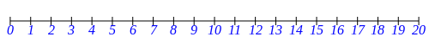  ......... is between 10 and 12  8 is between 7 and .........  16 is between ......... and 17 | [1]
8) Write in the missing numbers  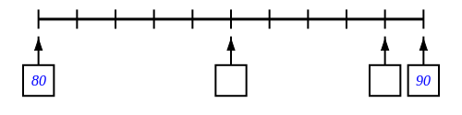 | [1]
9) Write in the missing numbers  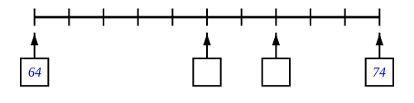 | [1]
10) How many small blocks are there altogether? ......... | [1]
Solutions for the assessment Place value and number facts
1) 2

2)
28 $=$ 20 $+$ 8 73 $=$ 70 $+$ 3

3) 19, 81, 89, 91 | 4) 66 67 68 69 70
5) 22 43 47 61 98 | 6) 44 > 18
7) 11, 9, 15 | 8) missing numbers are 85 and 89
9) missing numbers are 69 and 71 | 10) 74

