Place value and number facts
Name : | Class : | Date :

Mark : | /10 | %

1) Write down the digit that means units in 97 ......... | [1]
2) Partition the numbers and complete the number sentences.  36 $=$ ....... $+$ ....... 85 $=$ ....... $+$ ....... | [1]
3) Write an ordered list of 2 digit numbers from the three numbers below.  9 6 7  67 ....... ....... ....... ....... 97  smallest largest | [1]
4) Write 57 in the correct place in the number square.  41 42 43 44 45  46 47 48 49 50 | [1]
5) Put these numbers in order of size, starting with the smallest number.  97 44 76 56 20  ...... ...... ...... ...... ......  smallest largest | [1]
6) Use $<$ or $>$ to make a true statement.  17 ...... 49 | [1]
7) Complete the number sentences using the number line.  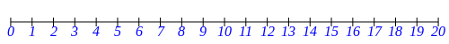  ......... is between 10 and 12  14 is between 13 and .........  6 is between ......... and 7 | [1]
8) Write in the missing numbers | [1]
9) Write in the missing numbers  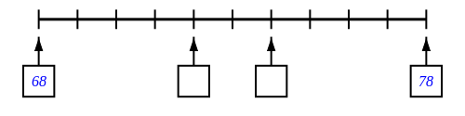 | [1]
10) How many small blocks are there altogether? ......... | [1]
Solutions for the assessment Place value and number facts
1) 7

2)
36 $=$ 30 $+$ 6 85 $=$ 80 $+$ 5

3) 69, 76, 79, 96 | 4) 56 57 58 59 60
5) 20 44 56 76 97 | 6) 17 < 49
7) 11, 15, 5 | 8) missing numbers are 23 and 27
9) missing numbers are 72 and 74 | 10) 89

