Multiplication in context
Name : | Class : | Date :

Mark : | /8 | %

1) There are 7 peaches in a box.  How many peaches are there in 6 boxes? ......... peaches | [1]
2) There are 6 bananas in a box.  How many bananas are there in 4 boxes? ......... bananas | [1]
3) A cinema has 37 rows of 38 people.  How many people are there? ......... | [1]
4) A meeting room has 17 rows of 91 people.  How many people are there? ......... | [1]
5) A field has length 186 metres and width 146 metres.  What is the area of the field? ......... m²  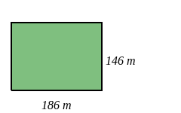 | [1]
6) A field has length 150 metres and width 173 metres.  What is the area of the field? ......... m²  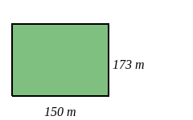 | [1]
7) Using the number line, start at 3 and make three jumps of 5.  Which number do you finish on? .........  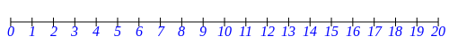 | [1]
8) Using the number line, start at 3 and make three jumps of 3.  Which number do you finish on? .........  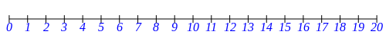 | [1]
Solutions for the assessment Multiplication in context
1) 42 peaches | 2) 24 bananas
3) 37 $×$ 38 = 1406 | 4) 17 $×$ 91 = 1547
5) Area = 186 $×$ 146 = 27156 $m^{2}$ | 6) Area = 150 $×$ 173 = 25950 $m^{2}$
7) 18 | 8) 12

