Multiplication in context
Name : | Class : | Date :

Mark : | /8 | %

1) There are 9 pears in a box.  How many pears are there in 5 boxes? ......... pears | [1]
2) There are 6 melons in a box.  How many melons are there in 7 boxes? ......... melons | [1]
3) A cinema has 81 rows of 71 people.  How many people are there? ......... | [1]
4) A theatre has 95 rows of 67 people.  How many people are there? ......... | [1]
5) A field has length 181 metres and width 104 metres.  What is the area of the field? ......... m²  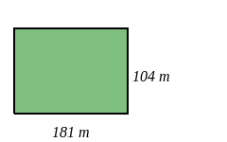 | [1]
6) A field has length 116 metres and width 120 metres.  What is the area of the field? ......... m²  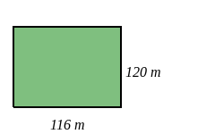 | [1]
7) Using the number line, start at 1 and make three jumps of 2.  Which number do you finish on? .........  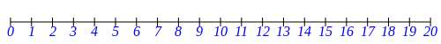 | [1]
8) Using the number line, start at 3 and make two jumps of 5.  Which number do you finish on? .........  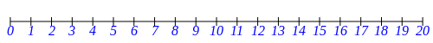 | [1]
Solutions for the assessment Multiplication in context
1) 45 pears | 2) 42 melons
3) 81 $×$ 71 = 5751 | 4) 95 $×$ 67 = 6365
5) Area = 181 $×$ 104 = 18824 $m^{2}$ | 6) Area = 116 $×$ 120 = 13920 $m^{2}$
7) 7 | 8) 13

