Multiplication in context
Name : | Class : | Date :

Mark : | /8 | %

1) There are 6 apples in a box.  How many apples are there in 7 boxes? ......... apples | [1]
2) There are 4 pears in a box.  How many pears are there in 7 boxes? ......... pears | [1]
3) A cinema has 53 rows of 61 people.  How many people are there? ......... | [1]
4) A meeting room has 18 rows of 28 people.  How many people are there? ......... | [1]
5) A field has length 109 metres and width 198 metres.  What is the area of the field? ......... m²  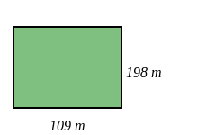 | [1]
6) A field has length 126 metres and width 177 metres.  What is the area of the field? ......... m²  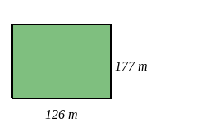 | [1]
7) Using the number line, start at 2 and make three jumps of 2.  Which number do you finish on? .........  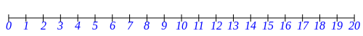 | [1]
8) Using the number line, start at 2 and make three jumps of 3.  Which number do you finish on? .........  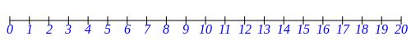 | [1]
Solutions for the assessment Multiplication in context
1) 42 apples | 2) 28 pears
3) 53 $×$ 61 = 3233 | 4) 18 $×$ 28 = 504
5) Area = 109 $×$ 198 = 21582 $m^{2}$ | 6) Area = 126 $×$ 177 = 22302 $m^{2}$
7) 8 | 8) 11

