 | R15h |  | Interpret the gradient at a point on a curve as the instantaneous rate of change; apply the concepts of average and instantaneous rate of change (gradients of chords and tangents) in numerical, algebraic and graphical contexts

Teaching Guidance
Students should be able to:
- draw a tangent at a point on a curve and measure the gradient
- interpret the meaning of the gradient as the rate of change of the variable on the vertical axis
compared to the horizontal axis
- understand that if the vertical axis represents speed / velocity and the horizontal axis represents time then the gradient will represent acceleration
- understand that if the vertical axis represents distance and the horizontal axis represents time then the gradient will represent speed / velocity
- understand the difference between positive and negative gradients as rates of change
- understand that the rate of change at a particular instant in time is represented by the gradient of the tangent to the curve at that point
- understand that the average rate of change is represented by a chord.
Notes
Velocity will be given as, for example, m/s and acceleration will be given as, for example, m/s2
See A15h

 | Examples
 | 1 | The graph shows the height of a firework rocket above the ground plotted against time after take-off.
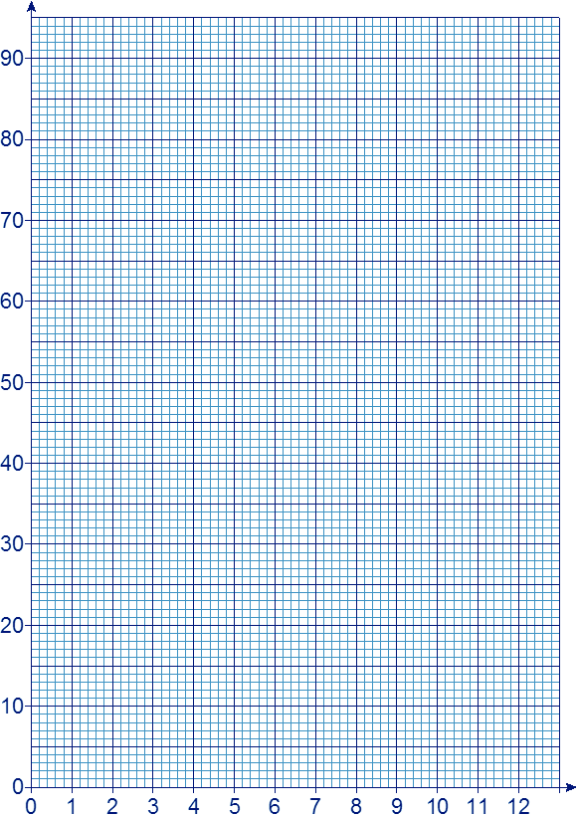
Height
(metres)
Time
(seconds)
 |  | (a) | Use the graph to find the greatest height reached by the rocket.
 |  | (b) | How long is the rocket moving upwards?
 |  | (c) | By drawing a suitable straight-line graph, estimate the speed of the rocket two seconds after take-off.
 |  | (d) | When is the rocket rising at its fastest speed?

 |  |  |  | (e) | On the axes below, sketch the velocity-time graph for the rise of the rocket.
(Graph will be drawn full size)
time (s)
O
5
1000
velocity
(m / s)

