 | A15h |  | Calculate or estimate gradients of graphs and areas under graphs (including quadratic and other  non-linear graphs), and interpret results in cases such as distance-time graphs, velocity-time graphs and graphs in financial contexts

Teaching Guidance
Students should be able to:
- calculate the area under a graph consisting of straight lines
- estimate the gradient at a point on a curve by drawing a tangent at that point and working out its gradient
- interpret the meaning (and give the units) of the gradient at a point on a curve
- use the areas of trapezia, triangles and rectangles to estimate the area under a curve
- interpret the meaning of the area calculated as the product of the units of the variable on the vertical axis and the units of the variable on the horizontal axis.
Notes
The trapezium rule need not be known but it is recommended as the most efficient means of calculating the area under a curve.
Students should know that the area under a speed-time graph represents distance.
Students should know that if the vertical axis represents distance on a distance-time graph, then the gradient will represent speed.
Students should know that if the vertical axis represents velocity on a velocity-time graph, then the gradient will represent acceleration.
Students should understand the difference between positive and negative gradients as increasing speed and decreasing speed on a distance-time graph.
Students should know that the rate of change at a particular instant in time is represented by the gradient of the tangent to the curve at that point.
See A14, R14, R15h

 | Examples
 | 1 | The graph shows the speed of a car between two sets of traffic lights.  It achieves a maximum speed of v metres per second.  It travels for 50 seconds.  The distance between the traffic lights is 625 metres.  Not drawn accurately  Speed (m/s)  0 20 40 50  0  Time (s)  v  Calculate the value of v.
 | 2 | The graph shows the speed of a train between two stations.  Speed (m/s)  0 20 40 50  50  0  Time (s)  Not drawn accurately  Calculate the distance between the stations.

 | 3 |  | The graph shows the speed-time graph of a car.  (Drawn on graph paper with axes and values clearly marked)  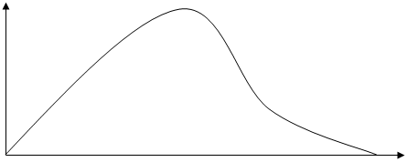  Time  Speed  Use the graph to work out
 |  |  |  | (a) | The maximum speed of the car.
 |  |  |  | (b) | The total distance travelled.
 |  |  |  | (c) | The average speed for the journey.
 |  |  |  | (d) | The deceleration of the car after 8 seconds.

 | 4 | The graph shows the speed of a car between two sets of traffic lights.  It achieves a maximum speed of v metres per second.  It travels for 50 seconds.
 | Speed (m/s) | Time (s)  0 4 10 50  Time, (secs)  v  10  0  t
 |  | (a) | Calculate the acceleration of the car during the first 4 seconds.
 |  | (b) | Describe how the motion of the car changes at the end of the tenth second.
 |  | (c) | The car decelerates for the last t seconds of the motion.  The distance travelled whilst decelerating is 75 metres.  Show that tv = 150
 |  | (d) | The distance travelled at constant speed is 450 metres.  Show that 40v − tv = 450
 |  | (e) | Hence, or otherwise, find the total distance between the two sets of traffic lights.

 | 5 | The graph shows the height of a firework rocket above the ground plotted against time after take-off.
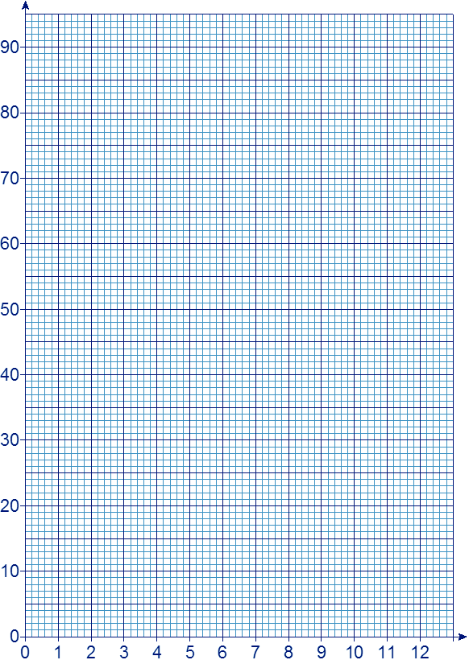
Height
(metres)
Time
(seconds)
 |  | (a) | Use the graph to find the greatest height reached by the rocket.
 |  | (b) | How long is the rocket moving upwards?
 |  | (c) | When is the rocket rising at its fastest speed?

