Proof of Pick’s theorem
(Wikipedia https://en.wikipedia.org/wiki/Pick%27s_theorem)
Consider a polygon P and a triangle T, with one edge in common with P. Assume Pick's theorem is true for both P and T separately; we want to show that it is also true for the polygon PT obtained by adding T to P. Since P and T share an edge, all the boundary points along the edge in common are merged to interior points, except for the two endpoints of the edge, which are merged to boundary points. So, calling the number of boundary points in common c, we have^{[3]}
and
From the above follows
and
Since we are assuming the theorem for P and for T separately,
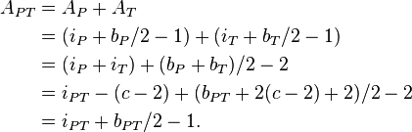
Therefore, if the theorem is true for polygons constructed from n triangles, the theorem is also true for polygons constructed from n + 1 triangles. For general polytopes, it is well known that they can always be triangulated. That this is true in dimension 2 is an easy fact. To finish the proof by mathematical induction, it remains to show that the theorem is true for triangles. The verification for this case can be done in these short steps:
- observe that the formula holds for any unit square (with vertices having integer coordinates);
- deduce from this that the formula is correct for any rectangle with sides parallel to the axes;
- deduce it, now, for right-angled triangles obtained by cutting such rectangles along a diagonal;
- now any triangle can be turned into a rectangle by attaching such right triangles; since the formula is correct for the right triangles and for the rectangle, it also follows for the original triangle.
The last step uses the fact that if the theorem is true for the polygon PT and for the triangle T, then it's also true for P; this can be seen by a calculation very much similar to the one shown above.

