Probability - Dependent Events
Name : | Class : | Date :

Mark : | /8 | %

1) The tree diagram below shows the outcomes of choosing two marbles out of a jar that contains 3 purple marbles and 7 green marbles.  Find the probability of that both marbles are purple.  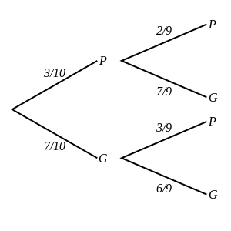 | [1]
2) The tree diagram below shows the outcomes of choosing and eating two chocolates from a box containing 7 dark chocolates, 3 white chocolates and 4 milk chocolates.  Find the probability of eating one white and one milk chocolate.  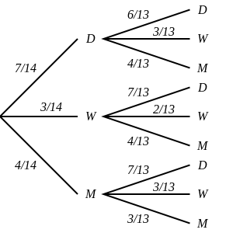 | [1]
3) The tree diagram below shows the outcomes of selecting three counters from a jar containing 4 green counters and 3 pink counters.  Note that a counter is not replaced before the next is selected.  Find the probability of picking three green counters.  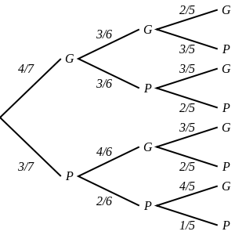 | [1]
4) The tree diagram below shows the outcomes of choosing and eating three chocolates from a box containing 4 dark chocolates and 3 milk chocolates.  Find the probability of eating at least one dark chocolate.  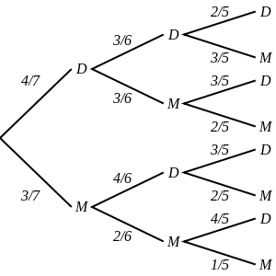 | [1]
5) A jar contains 5 purple marbles and 3 red marbles. James randomly selects 2 marbles at the same time.  Draw a tree diagram and use it to calculate the probability that both marbles are purple. | [1]
6) A box contains 7 milk chocolates, 4 nut chocolates and 6 raisin chocolates.  Draw a tree diagram and use it to calculate the probability of eating one nut and one raisin chocolate. | [1]
7) Joseph selected three counters from a box containing 6 white counters and 4 yellow counters. He did not replaced any of the balls before the next was selected.  Calculate the probability that he picked at least one white counter. | [1]
8) The outcomes of selecting three chocolates from a box containing 6 mint chocolates and 4 raisin chocolates without replacement.  Draw a tree diagram and use it to calculate the probability of picking three raisin chocolates. | [1]
Solutions for the assessment Probability - Dependent Events
1) P(both marbles are purple) = 1/15 | 2) P(one white and one milk chocolate) = 12/91
3) P(3G) = 4/35 | 4) P(at least one D) = 34/35
5) P(both marbles are purple) = 5/14
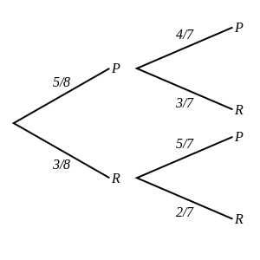

6) P(one nut and one raisin chocolate) = 3/17
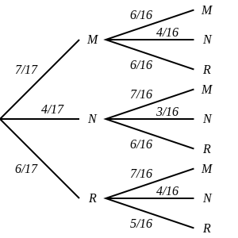

7) P(at least one W) = 29/30
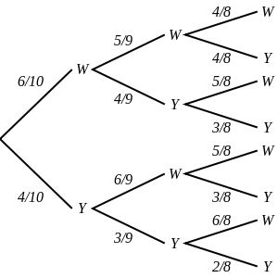

8) P(3R) = 1/30
