Probability - Dependent Events
Name : | Class : | Date :

Mark : | /8 | %

1) The tree diagram below shows the outcomes of choosing two marbles out of a jar that contains 3 red marbles and 5 yellow marbles.  Find the probability of that one marble is yellow and the other is red.  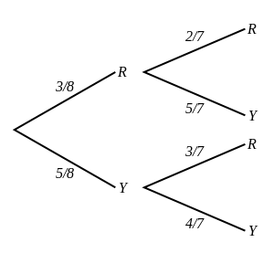 | [1]
2) The tree diagram below shows the outcomes of choosing and eating two chocolates from a box containing 7 white chocolates, 3 orange chocolates and 5 nut chocolates.  Find the probability of eating one white and one orange chocolate.  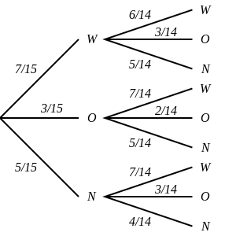 | [1]
3) The tree diagram below shows the outcomes of selecting three beads from a box containing 3 pink beads and 6 red beads.  Note that a bead is not replaced before the next is selected.  Find the probability of picking one pink and two red beads.  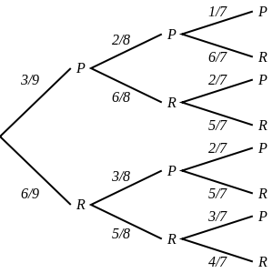 | [1]
4) The tree diagram below shows the outcomes of choosing and eating three chocolates from a box containing 4 orange chocolates and 5 mint chocolates.  Find the probability of eating three orange chocolates.  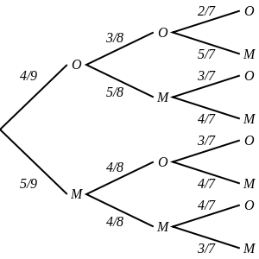 | [1]
5) A jar contains 2 green marbles and 5 purple marbles. Aidan randomly selects 2 marbles at the same time.  Draw a tree diagram and use it to calculate the probability that one marble is purple and the other is green. | [1]
6) A box contains 3 raisin chocolates, 5 milk chocolates and 7 nut chocolates.  Draw a tree diagram and use it to calculate the probability of eating one milk and one nut chocolate. | [1]
7) Skye selected three beads from a bag containing 5 white beads and 6 green beads. She did not replaced any of the balls before the next was selected.  Calculate the probability that she picked three green beads. | [1]
8) The outcomes of selecting three chocolates from a box containing 5 raisin chocolates and 3 dark chocolates without replacement.  Draw a tree diagram and use it to calculate the probability of picking one raisin and two dark chocolates. | [1]
Solutions for the assessment Probability - Dependent Events
1) P(one marble is yellow and the other is red) = 15/28 | 2) P(one white and one orange chocolate) = 1/5
3) P(one P and two R) = 15/28 | 4) P(3O) = 1/21
5) P(one marble is purple and the other is green) = 10/21
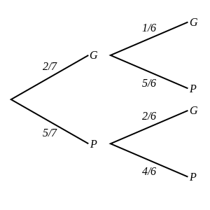

6) P(one milk and one nut chocolate) = 1/3
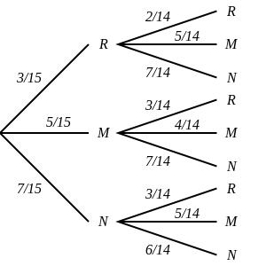

7) P(3G) = 4/33
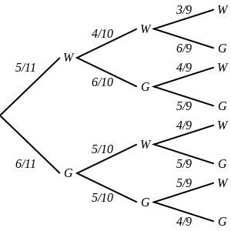

8) P(one R and two D) = 15/56
