Probability - Dependent Events
Name : | Class : | Date :

Mark : | /8 | %

1) The tree diagram below shows the outcomes of choosing two marbles out of a jar that contains 5 purple marbles and 4 red marbles.  Find the probability of that both marbles are red.  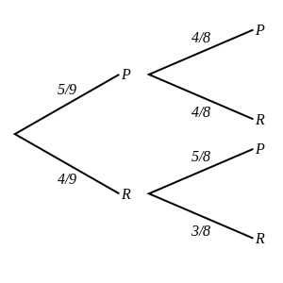 | [1]
2) The tree diagram below shows the outcomes of choosing and eating two chocolates from a box containing 7 milk chocolates, 4 raisin chocolates and 3 white chocolates.  Find the probability of eating one milk and one raisin chocolate.  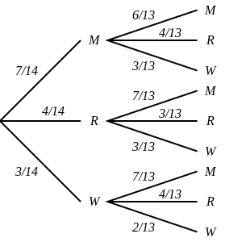 | [1]
3) The tree diagram below shows the outcomes of selecting three balls from a box containing 4 pink balls and 3 white balls.  Note that a ball is not replaced before the next is selected.  Find the probability of picking at least one pink ball.  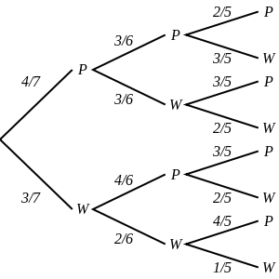 | [1]
4) The tree diagram below shows the outcomes of choosing and eating three chocolates from a box containing 4 milk chocolates and 6 dark chocolates.  Find the probability of eating one dark and two milk chocolates.  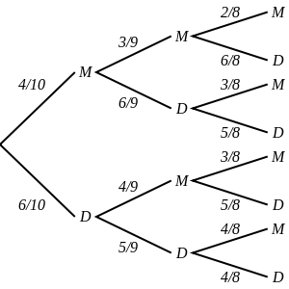 | [1]
5) A jar contains 3 blue marbles and 6 orange marbles. Lola randomly selects 2 marbles at the same time.  Draw a tree diagram and use it to calculate the probability that both marbles are blue. | [1]
6) A box contains 5 raisin chocolates, 7 nut chocolates and 6 white chocolates.  Draw a tree diagram and use it to calculate the probability of eating one nut and one raisin chocolate. | [1]
7) Benjamin selected three beads from a box containing 5 red beads and 3 blue beads. He did not replaced any of the balls before the next was selected.  Calculate the probability that he picked three red beads. | [1]
8) The outcomes of selecting three chocolates from a box containing 6 nut chocolates and 4 raisin chocolates without replacement.  Draw a tree diagram and use it to calculate the probability of picking at least one nut chocolate. | [1]
Solutions for the assessment Probability - Dependent Events
1) P(both marbles are red) = 1/6 | 2) P(one milk and one raisin chocolate) = 4/13
3) P(at least one P) = 34/35 | 4) P(one D and two M) = 3/10
5) P(both marbles are blue) = 1/12
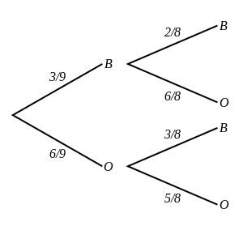

6) P(one nut and one raisin chocolate) = 35/153
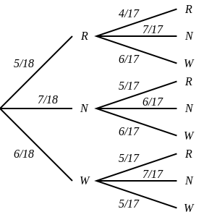

7) P(3R) = 5/28
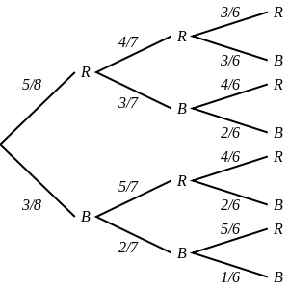

8) P(at least one N) = 29/30
