Probability - Tree Diagrams (2 independent events)
Name : | Class : | Date :

Mark : | /8 | %

1) The tree diagram below shows the outcomes of tossing a fair coin twice.  Find the probability of getting two tails.  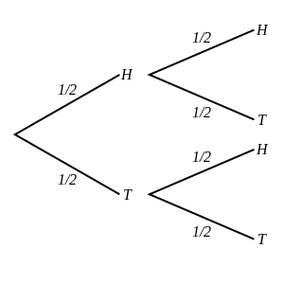 | [1]
2) A coin is tossed and a dice is thrown.  Find the probability of getting tails and a 3.  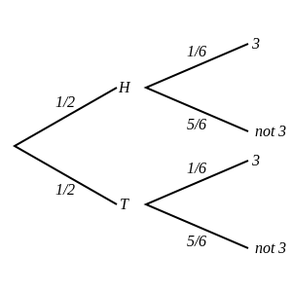 | [1]
3) The tree diagram below shows the outcomes of choosing two marbles out of a jar that contains 6 red marbles and 4 green marbles.  Note that the first marble is returned to the jar before the second is picked.  Find the probability that one marble is red and the other is green.  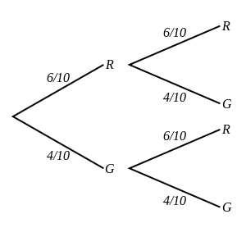 | [1]
4) The tree diagram below shows the outcomes of picking two marbles out of a bag that contains 2 green marbles, 3 red marbles and 5 yellow marbles.  Note that the first marble is returned to the bag before the second is picked.  Find the probability that one marble is green and the other is red.  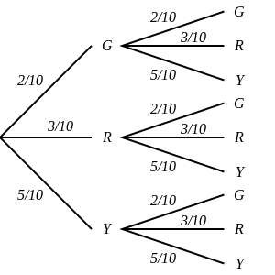 | [1]
5) A fair coin is tossed twice.  Draw a tree diagram and use it to calculate the probability of a tail and a head. | [1]
6) A coin is tossed and a dice is thrown.  Draw a tree diagram and use it to calculate the probability of heads and a 2. | [1]
7) One marble is picked out of a jar that contains 4 orange marbles and 7 purple marbles and returned to the jar.  A second marble is then chosen from the same jar.  Draw a tree diagram and use it to calculate the probability that both are purple. | [1]
8) Two marbles are picked out of a jar that contains 3 green marbles, 5 red marbles and 6 yellow marbles.  Note that the first marble is returned to the jar before the second is picked.  Draw a tree diagram and use it to calculate the probability that one is green and the other is red. | [1]
Solutions for the assessment Probability - Tree Diagrams (2 independent events)
1) P(two tails) = 1/4 | 2) P(tails and a 3) = 1/12
3) P(one marble is red and the other is green) = 12/25 | 4) P(one marble is green and the other is red) = 3/25
5) P(a tail and a head) = 1/2
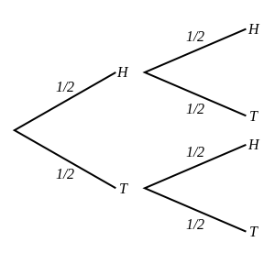

6) P(heads and a 2) = 1/12
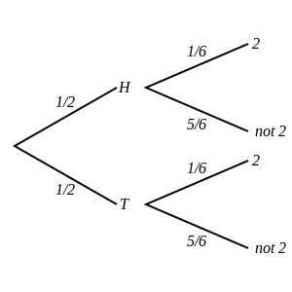

7) P(both are purple) = 49/121
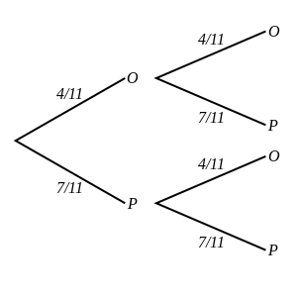

8) P(one is green and the other is red) = 15/98
