Probability - Tree Diagrams (2 independent events)
Name : | Class : | Date :

Mark : | /8 | %

1) The tree diagram below shows the outcomes of tossing a fair coin twice.  Find the probability of getting two heads.  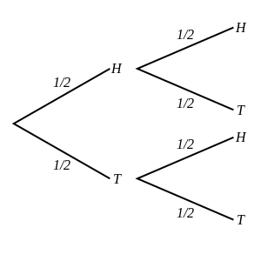 | [1]
2) A coin is tossed and a dice is thrown.  Find the probability of getting heads and a 1.  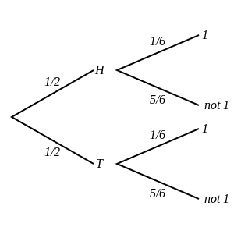 | [1]
3) The tree diagram below shows the outcomes of choosing two marbles out of a jar that contains 3 green marbles and 6 orange marbles.  Note that the first marble is returned to the jar before the second is picked.  Find the probability that both marbles are orange.  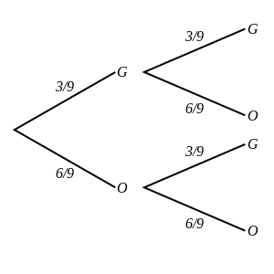 | [1]
4) The tree diagram below shows the outcomes of picking two marbles out of a jar that contains 4 red marbles, 3 yellow marbles and 2 orange marbles.  Note that the first marble is returned to the jar before the second is picked.  Find the probability that both marbles are orange.  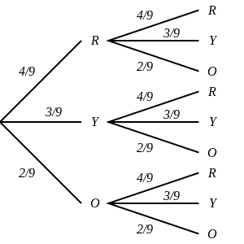 | [1]
5) A fair coin is tossed twice.  Draw a tree diagram and use it to calculate the probability of two tails. | [1]
6) A coin is tossed and a dice is thrown.  Draw a tree diagram and use it to calculate the probability of heads and a 4. | [1]
7) One marble is picked out of a jar that contains 3 orange marbles and 2 yellow marbles and returned to the jar.  A second marble is then chosen from the same jar.  Draw a tree diagram and use it to calculate the probability that one is yellow and the other is orange. | [1]
8) Two marbles are picked out of a jar that contains 3 purple marbles, 2 yellow marbles and 6 blue marbles.  Note that the first marble is returned to the jar before the second is picked.  Draw a tree diagram and use it to calculate the probability that both are purple. | [1]
Solutions for the assessment Probability - Tree Diagrams (2 independent events)
1) P(two heads) = 1/4 | 2) P(heads and a 1) = 1/12
3) P(both marbles are orange) = 4/9 | 4) P(both marbles are orange) = 4/81
5) P(two tails) = 1/4
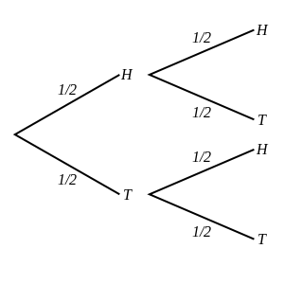

6) P(heads and a 4) = 1/12
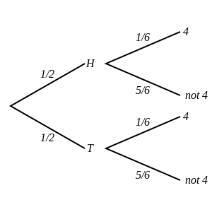

7) P(one is yellow and the other is orange) = 12/25
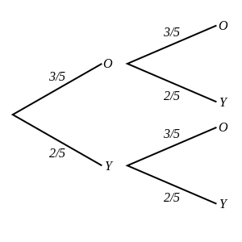

8) P(both are purple) = 9/121
