Probability - Tree Diagrams (2 independent events)
Name : | Class : | Date :

Mark : | /8 | %

1) The tree diagram below shows the outcomes of tossing a fair coin twice.  Find the probability of getting a tail and a head.  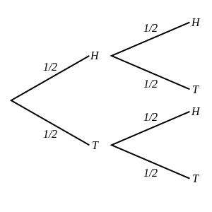 | [1]
2) A coin is tossed and a dice is thrown.  Find the probability of getting heads and a 3.  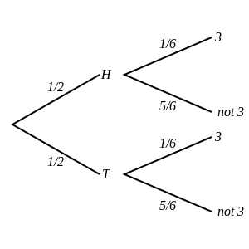 | [1]
3) The tree diagram below shows the outcomes of choosing two marbles out of a jar that contains 8 purple marbles and 6 blue marbles.  Note that the first marble is returned to the jar before the second is picked.  Find the probability that both marbles are purple.  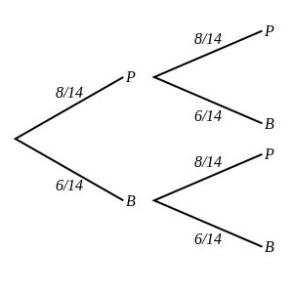 | [1]
4) The tree diagram below shows the outcomes of picking two marbles out of a pot that contains 4 yellow marbles, 2 red marbles and 6 green marbles.  Note that the first marble is returned to the pot before the second is picked.  Find the probability that both marbles are red.  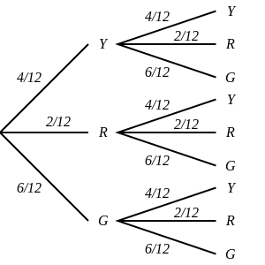 | [1]
5) A fair coin is tossed twice.  Draw a tree diagram and use it to calculate the probability of a head and a tail. | [1]
6) A coin is tossed and a dice is thrown.  Draw a tree diagram and use it to calculate the probability of tails and not a 2. | [1]
7) One marble is picked out of a jar that contains 8 blue marbles and 4 yellow marbles and returned to the jar.  A second marble is then chosen from the same jar.  Draw a tree diagram and use it to calculate the probability that one is yellow and the other is blue. | [1]
8) Two marbles are picked out of a bag that contains 3 green marbles, 2 orange marbles and 4 red marbles.  Note that the first marble is returned to the bag before the second is picked.  Draw a tree diagram and use it to calculate the probability that both are red. | [1]
Solutions for the assessment Probability - Tree Diagrams (2 independent events)
1) P(a tail and a head) = 1/2 | 2) P(heads and a 3) = 1/12
3) P(both marbles are purple) = 16/49 | 4) P(both marbles are red) = 1/36
5) P(a head and a tail) = 1/2
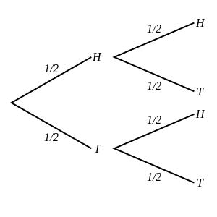

6) P(tails and not a 2) = 5/12
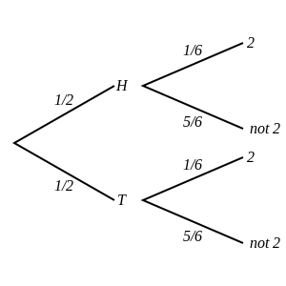

7) P(one is yellow and the other is blue) = 4/9
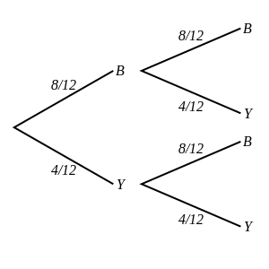

8) P(both are red) = 16/81
