Scattergraphs
Name : | Class : | Date :

Mark : | /4 | %

1) Construct a scatterplot for the data about Maths and English test scores for a group of students given below.  Maths English  8 3  6 2  7 7  1 1  3 6 | [1]
2) Construct a scatterplot and draw a line of best fit for the quiz scores for 8 students in a class.  1st quiz 2nd Quiz  10 8  12 9  13 10  16 12  19 13  22 22  27 29  50 45 | [1]
3) Plot the mean point ( $\overline{x}$, $\overline{y}$) and draw a line of best fit for the quiz scores for 8 students in a class.  1st quiz 2nd Quiz  12 9  16 10  19 18  33 26  34 29  35 35  39 39  49 39 | [1]
4) Here is a scatter plot for a set of bivariate data.  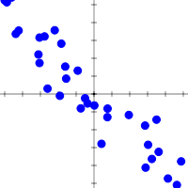  Describe the correlation shown in the scatterplot using 3 words from the list below.  weak strong positive negative correlation | [1]
Solutions for the assessment Scattergraphs
1) 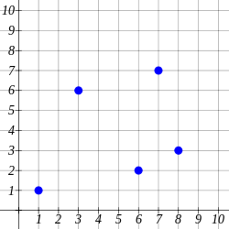

2) 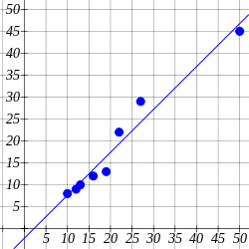

3) 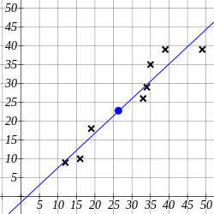

4) strong negative correlation

