Scattergraphs
Name : | Class : | Date :

Mark : | /4 | %

1) Construct a scatterplot for the data about Maths and English test scores for a group of students given below.  Maths English  7 7  3 1  5 2  2 5  6 3 | [1]
2) Construct a scatterplot and draw a line of best fit for the quiz scores for 8 students in a class.  1st quiz 2nd Quiz  14 16  28 22  34 33  36 35  43 38  45 39  46 43  49 43 | [1]
3) Plot the mean point ( $\overline{x}$, $\overline{y}$) and draw a line of best fit for the quiz scores for 8 students in a class.  1st quiz 2nd Quiz  10 5  11 6  13 12  15 13  22 18  29 22  48 46  50 49 | [1]
4) Here is a scatter plot for a set of bivariate data.  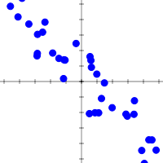  Describe the correlation shown in the scatterplot using 3 words from the list below.  weak strong positive negative correlation | [1]
Solutions for the assessment Scattergraphs
1) 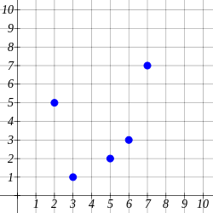

2) 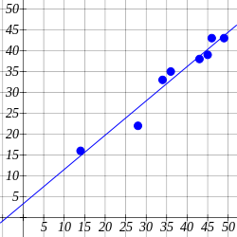

3) 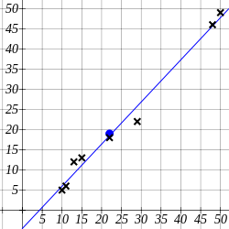

4) strong negative correlation

