Scattergraphs
Name : | Class : | Date :

Mark : | /4 | %

1) Construct a scatterplot for the data about Maths and English test scores for a group of students given below.  Maths English  3 6  1 4  8 5  2 3  7 8 | [1]
2) Construct a scatterplot and draw a line of best fit for the quiz scores for 8 students in a class.  1st quiz 2nd Quiz  29 21  31 29  36 30  37 36  39 39  40 40  41 40  42 42 | [1]
3) Plot the mean point ( $\overline{x}$, $\overline{y}$) and draw a line of best fit for the quiz scores for 8 students in a class.  1st quiz 2nd Quiz  10 12  24 20  32 26  34 30  35 33  37 35  40 37  45 40 | [1]
4) Here is a scatter plot for a set of bivariate data.  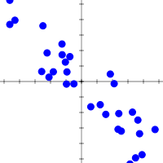  Describe the correlation shown in the scatterplot using 3 words from the list below.  weak strong positive negative correlation | [1]
Solutions for the assessment Scattergraphs
1) 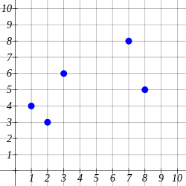

2) 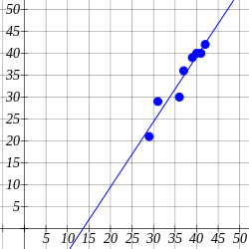

3) 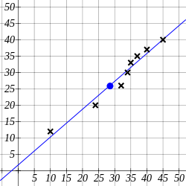

4) strong negative correlation

