Histograms
Name : | Class : | Date :

Mark : | /7 | %

1) The table below shows the heights of 20 people.  Complete the table to show the frequency densities, rounding your answer to 1 decimal place.  Height Frequency Frequency Density  140 $≤$ h $<$ 145 3  145 $≤$ h $<$ 155 7  155 $≤$ h $<$ 165 5  165 $≤$ h $<$ 180 12 | [1]
2) The histogram below shows the distribution of heights (cm) of 900 people.  Complete the table to show the frequency density and frequency for each class.  Height Frequency Density Frequency  140 $≤$ h $<$ 145  145 $≤$ h $<$ 155  155 $≤$ h $<$ 165  165 $≤$ h $<$ 180 | [1]
3) The histogram below shows the distribution of heights (cm) of 1000 people.  Complete the table to show the frequency for each class.  Height Frequency  140 $≤$ h $<$ 150  150 $≤$ h $<$ 165  165 $≤$ h $<$ 170  170 $≤$ h $<$ 180 | [1]
4) The table below shows the height, in metres, of 700 trees.  Use the table to fill in the missing bar in the histogram.  Height Frequency  0 $≤$ h $<$ 10 188  10 $≤$ h $<$ 25 265  25 $≤$ h $<$ 30 94  30 $≤$ h $<$ 40 153 | [1]
5) The table below shows the heights of 900 people. Calculate the frequency densities for each class and construct a histogram.  Height Frequency Frequency Density  140 $≤$ h $<$ 145 100  145 $≤$ h $<$ 160 343  160 $≤$ h $<$ 170 213  170 $≤$ h $<$ 180 244 | [1]
6) The histogram below shows the distribution of weekly salary ($) of 800 workers.  Complete the table to show the frequency for each class.  Height Frequency  140 $≤$ h $<$ 145  145 $≤$ h $<$ 155  155 $≤$ h $<$ 165  165 $≤$ h $<$ 180 | [1]
7) The incomplete table and histogram give some information about weekly salary ($) of 800 workers.  Use the information in the histogram to complete the table and hence find the value of the frequency density for the missing bar in the histogram.  Height Frequency  140 $≤$ h $<$ 150 220  150 $≤$ h $<$ 165 210  165 $≤$ h $<$ 170  170 $≤$ h $<$ 180 | [1]
Solutions for the assessment Histograms
1) 0.6,0.7,0.5,0.8 | 2) fd: 21,23,22,23  frequency: 106,232,220,342
3) 246,410,116,228

4) 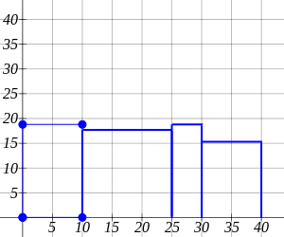

5) 20,22.9,21.3,24.4
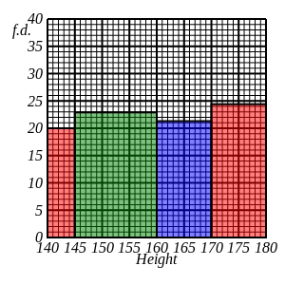

6) 93,204,208,295

7) Tables values are: 150, 220
Frequency density of missing bar is 22
