Histograms
Name : | Class : | Date :

Mark : | /7 | %

1) The table below shows the heights of 20 people.  Complete the table to show the frequency densities, rounding your answer to 1 decimal place.  Height Frequency Frequency Density  140 $≤$ h $<$ 145 4  145 $≤$ h $<$ 160 9  160 $≤$ h $<$ 170 13  170 $≤$ h $<$ 180 1 | [1]
2) The histogram below shows the distribution of heights (cm) of 900 people.  Complete the table to show the frequency density and frequency for each class.  Height Frequency Density Frequency  140 $≤$ h $<$ 150  150 $≤$ h $<$ 165  165 $≤$ h $<$ 170  170 $≤$ h $<$ 180 | [1]
3) The histogram below shows the distribution of heights (m) of 900 trees in metres.  Complete the table to show the frequency for each class.  Height Frequency  140 $≤$ h $<$ 150  150 $≤$ h $<$ 165  165 $≤$ h $<$ 170  170 $≤$ h $<$ 180 | [1]
4) The table below shows the height, in metres, of 1000 trees.  Use the table to fill in the missing bar in the histogram.  Height Frequency  0 $≤$ h $<$ 10 257  10 $≤$ h $<$ 25 377  25 $≤$ h $<$ 30 131  30 $≤$ h $<$ 40 235 | [1]
5) The table below shows the heights of 900 people. Calculate the frequency densities for each class and construct a histogram.  Height Frequency Frequency Density  140 $≤$ h $<$ 145 114  145 $≤$ h $<$ 155 246  155 $≤$ h $<$ 165 208  165 $≤$ h $<$ 180 332 | [1]
6) The histogram below shows the distribution of heights (cm) of 1000 people.  Complete the table to show the frequency for each class.  Height Frequency  140 $≤$ h $<$ 145  145 $≤$ h $<$ 160  160 $≤$ h $<$ 170  170 $≤$ h $<$ 180 | [1]
7) The incomplete table and histogram give some information about heights (cm) of 900 people.  Use the information in the histogram to complete the table and hence find the value of the frequency density for the missing bar in the histogram.  Height Frequency  140 $≤$ h $<$ 145 155  145 $≤$ h $<$ 160 225  160 $≤$ h $<$ 170  170 $≤$ h $<$ 180 | [1]
Solutions for the assessment Histograms
1) 0.8,0.6,1.3,0.1 | 2) fd: 22,25,20,20  frequency: 224,375,98,203
3) 252,346,102,200

4) 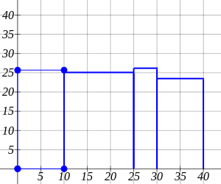

5) 22.8,24.6,20.8,22.1
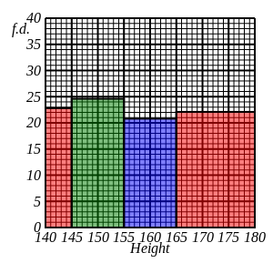

6) 124,392,235,249

7) Tables values are: 250, 270
Frequency density of missing bar is 31
