Frequency Polygons
Name : | Class : | Date :

Mark : | /4 | %

1) The table shows the weights in kg of fish. Draw a frequency polygon to represent this data.  Weight (kg) Frequency  0 $≤$ h $<$ 4 3  4 $≤$ h $<$ 8 11  8 $≤$ h $<$ 12 28  12 $≤$ h $<$ 16 27  16 $≤$ h $<$ 20 16  20 $≤$ h $<$ 24 9 | [1]
2) The table shows the heights in metres of trees in a park. Draw a frequency polygon to represent this data.  Height (m) Frequency  5 - 15 7  16 - 26 16  27 - 37 29  38 - 48 26  49 - 59 17  60 - 70 6 | [1]
3) The table shows the heights in metres of trees in a park. Draw a frequency polygon to represent this data and find the modal class interval.  Height (m) Frequency  10 $≤$ h $<$ 20 7  20 $≤$ h $<$ 30 19  30 $≤$ h $<$ 40 21  40 $≤$ h $<$ 50 28  50 $≤$ h $<$ 60 16  60 $≤$ h $<$ 70 3 | [1]
4) The table shows the heights in metres of trees in a park. Draw a frequency polygon to represent this data.  Height (m) Frequency  5 - 15 5  16 - 26 13  27 - 37 22  38 - 48 23  49 - 59 12  60 - 70 7 | [1]
Solutions for the assessment Frequency Polygons
1) 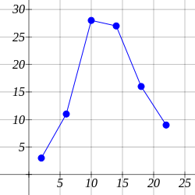

2) 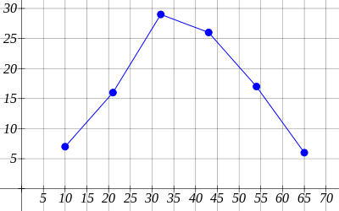

3)
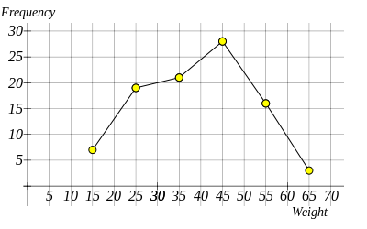
The modal class interval is 40 $≤$ h $<$ 50

4)
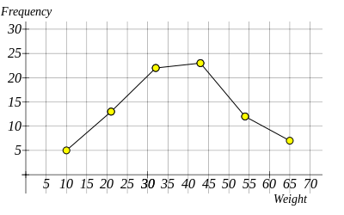
The modal class interval is 38 - 48

