Frequency Polygons
Name : | Class : | Date :

Mark : | /4 | %

1) The table shows the weights in kg of fish. Draw a frequency polygon to represent this data.  Weight (kg) Frequency  0 $≤$ h $<$ 4 4  4 $≤$ h $<$ 8 11  8 $≤$ h $<$ 12 24  12 $≤$ h $<$ 16 22  16 $≤$ h $<$ 20 19  20 $≤$ h $<$ 24 8 | [1]
2) The table shows the heights in metres of trees in a park. Draw a frequency polygon to represent this data.  Height (m) Frequency  5 - 15 5  16 - 26 13  27 - 37 21  38 - 48 27  49 - 59 19  60 - 70 4 | [1]
3) The table shows the heights in metres of trees in a park. Draw a frequency polygon to represent this data and find the modal class interval.  Height (m) Frequency  10 $≤$ h $<$ 20 7  20 $≤$ h $<$ 30 17  30 $≤$ h $<$ 40 20  40 $≤$ h $<$ 50 26  50 $≤$ h $<$ 60 11  60 $≤$ h $<$ 70 9 | [1]
4) The table shows the heights in metres of trees in a park. Draw a frequency polygon to represent this data.  Height (m) Frequency  5 - 15 3  16 - 26 18  27 - 37 21  38 - 48 28  49 - 59 11  60 - 70 4 | [1]
Solutions for the assessment Frequency Polygons
1) 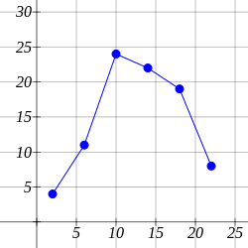

2) 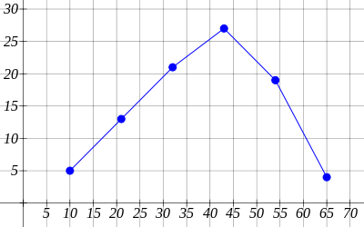

3)
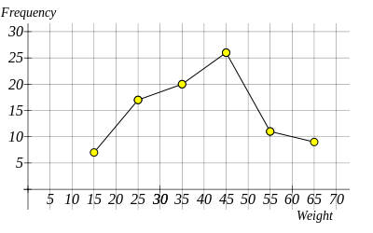
The modal class interval is 40 $≤$ h $<$ 50

4)
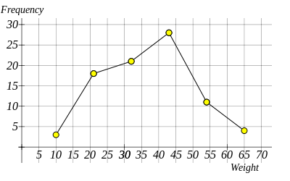
The modal class interval is 38 - 48

