Box Plot
Name : | Class : | Date :

Mark : | /6 | %

1) Find the median for the data contained in the boxplot.  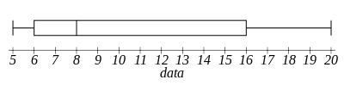 | [1]
2) Find the lower quartile for the data contained in the boxplot.  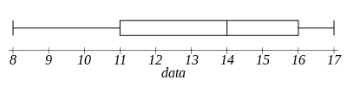 | [1]
3) Find the upper quartile for the data contained in the boxplot.  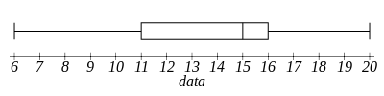 | [1]
4) Find the inter-quartile range for the data contained in the boxplot.  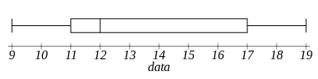 | [1]
5) The boxplot below shows salaries for Construction workers and Teachers.  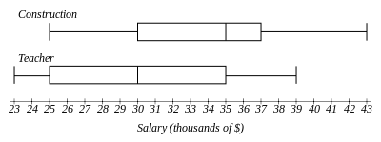 | [1]
6) Identify which one of the words below describes the skewness of the data in the box plot.  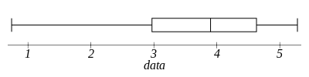  A. Symmetrical B. Negatively-skewed C. Positively-skewed | [1]
Solutions for the assessment Box Plot
1) 8 | 2) 11
3) 16 | 4) 6
5) 25 % | 6) B

