Box Plot
Name : | Class : | Date :

Mark : | /6 | %

1) Find the median for the data contained in the boxplot.  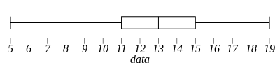 | [1]
2) Find the lower quartile for the data contained in the boxplot.  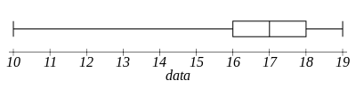 | [1]
3) Find the upper quartile for the data contained in the boxplot.  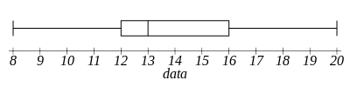 | [1]
4) Find the inter-quartile range for the data contained in the boxplot.  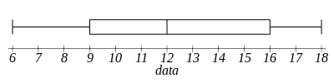 | [1]
5) The boxplot below shows salaries for Construction workers and Teachers.  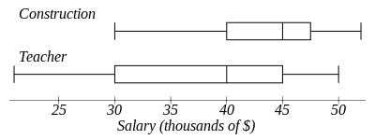 | [1]
6) Identify which one of the words below describes the skewness of the data in the box plot.  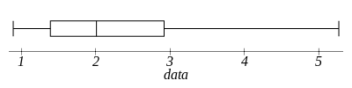  A. Symmetrical B. Positively-skewed C. Negatively-skewed | [1]
Solutions for the assessment Box Plot
1) 13 | 2) 16
3) 16 | 4) 7
5) 100 % | 6) B

