Cumulative Frequency
Name : | Class : | Date :

Mark : | /14 | %

1) Based on the frequency distribution below, find the cumulative frequency for the class with lower class limit 27  Ages 15 - 18 19 - 22 23 - 26 27 - 30 31 - 34 35 - 38  No. of Students 5 5 5 2 5 5 | [1]
2) 120 students took a test. The scores are summarized in the tables below.  Fill in the missing value in the frequency table.  Score Frequency 200 - 219 15 220 - 239 11 240 - 259 17 260 - 279 280 - 299 17 300 - 319 40 Score Cumulative Freq less than 220 15 less than 240 26 less than 260 43 less than 280 63 less than 300 80 less than 320 120 | [1]
3) The cumulative frequency polygon below shows the height of 20 trees, measured in metres.  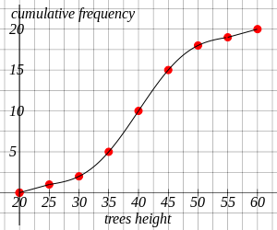  How many trees were less than 45 metres tall? | [1]
4) The cumulative frequency polygon below shows the height of 20 radio masts, measured in metres.  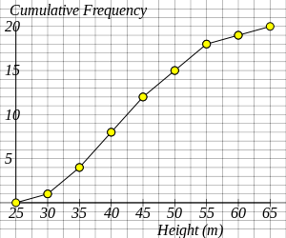  How many radio masts were greater than 55 metres tall? | [1]
5) The cumulative frequency polygon below shows the scores of 20 students in a physics test.  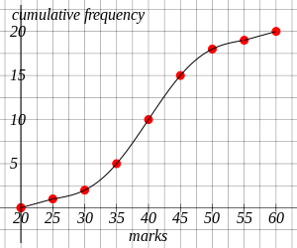  Estimate, using the graph, the number of students scoring less than 42?  (Give your answer to the nearest integer) | [1]
6) The cumulative frequency polygon below shows the scores of 20 students in a physics test.  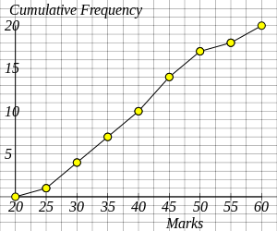  How many students scored more than 35 marks? | [1]
7) The cumulative frequency polygon below shows the number of minutes that 20 boys used a mobile phone in one day.  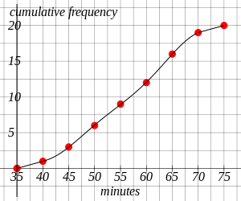  Estimate, using the graph, the median minutes of use?  (Give your answer to the nearest integer) | [1]
8) The cumulative frequency polygon below shows the number of minutes that 20 pupils used a website in one day.  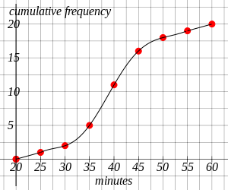  Estimate, using the graph, the lower quartile of the minutes of use?  (Give your answer to the nearest integer) | [1]
9) The cumulative frequency polygon below shows the number of minutes that 20 people used a mobile phone in one day.  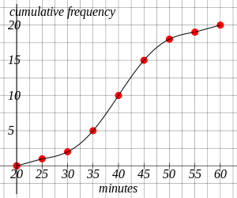  Estimate, using the graph, the upper quartile of the minutes of use?  (Give your answer to the nearest integer) | [1]
10) The cumulative frequency polygon below shows the number of minutes that 20 boys used a laptop in one day.  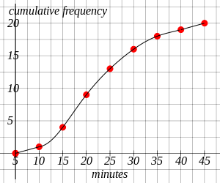  Estimate, using the graph, the interquartile range of the minutes of use?  (Give your answer to the nearest integer) | [1]
11) Using the table, complete the cumulative frequency graph showing the heights of 20 waterfalls, measured in metres.  Height of waterfalls Cumulative Frequency  h $≤$ 15 1  h $≤$ 20 4  h $≤$ 25 5  h $≤$ 30 6  h $≤$ 35 11  h $≤$ 40 15  h $≤$ 45 17  h $≤$ 50 20 | [1]
12) Complete the table and the cumulative frequency graph showing the heights of 20 buildings, measured in metres.  Height of buildings Frequency Cumulative Frequency  25 $≤$ h $<$ 30 1  30 $≤$ h $<$ 35 2  35 $≤$ h $<$ 40 2  40 $≤$ h $<$ 45 2  45 $≤$ h $<$ 50 3  50 $≤$ h $<$ 55 5  55 $≤$ h $<$ 60 3  60 $≤$ h $<$ 65 2 | [1]
13) The cumulative frequency table below shows the number of minutes that 20 women used a mobile phone in one day. Using the table complete the cumulative frequency graph and use your graph to estimate the median minutes of use (to the nearest integer).  Minutes Cumulative Frequency  10 $≤$ x $<$ 15 1  10 $≤$ x $<$ 20 4  10 $≤$ x $<$ 25 5  10 $≤$ x $<$ 30 6  10 $≤$ x $<$ 35 11  10 $≤$ x $<$ 40 15  10 $≤$ x $<$ 45 17  10 $≤$ x $<$ 50 20 | [1]
14) The cumulative frequency table below shows the number of minutes that 20 girls used a website in one day. Using the table complete the cumulative frequency graph and use your graph to estimate the interquartile range (to the nearest integer).  Minutes Cumulative Frequency  40 $≤$ x $<$ 45 1  40 $≤$ x $<$ 50 3  40 $≤$ x $<$ 55 5  40 $≤$ x $<$ 60 7  40 $≤$ x $<$ 65 11  40 $≤$ x $<$ 70 16  40 $≤$ x $<$ 75 18  40 $≤$ x $<$ 80 20 | [1]
Solutions for the assessment Cumulative Frequency
1) 17 | 2) The missing value is 20.
3) 15 | 4) 2
5) 12 | 6) 13
7) 57 minutes | 8) 35 minutes
9) 45 minutes | 10) 12 minutes
11)
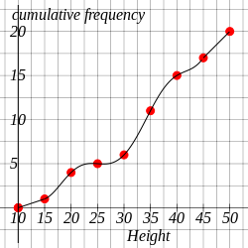

12) Cumulative Frequencies are 1, 3, 5, 7, 10, 15, 18, 20.
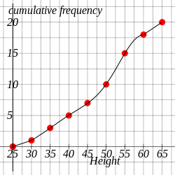

13) Median = 34 minutes
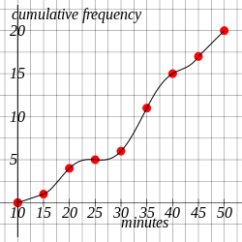

14) IQR = 14 minutes
