Cumulative Frequency
Name : | Class : | Date :

Mark : | /14 | %

1) Based on the frequency distribution below, find the cumulative frequency for the class with lower class limit 31  Ages 15 - 18 19 - 22 23 - 26 27 - 30 31 - 34 35 - 38  No. of Students 2 2 4 7 4 10 | [1]
2) 120 students took a test. The scores are summarized in the tables below.  Fill in the missing value in the frequency table.  Score Frequency 100 - 109 19 110 - 119 17 120 - 129 14 130 - 139 140 - 149 16 150 - 159 40 Score Cumulative Freq less than 110 19 less than 120 36 less than 130 50 less than 140 64 less than 150 80 less than 160 120 | [1]
3) The cumulative frequency polygon below shows the height of 20 buildings, measured in metres.  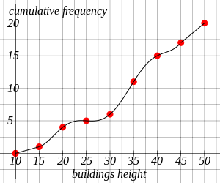  How many buildings were less than 25 metres tall? | [1]
4) The cumulative frequency polygon below shows the height of 20 buildings, measured in metres.  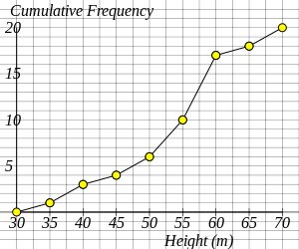  How many buildings were greater than 50 metres tall? | [1]
5) The cumulative frequency polygon below shows the scores of 20 students in a history test.  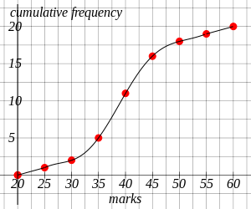  Estimate, using the graph, the number of students scoring less than 41?  (Give your answer to the nearest integer) | [1]
6) The cumulative frequency polygon below shows the scores of 20 students in a computer test.  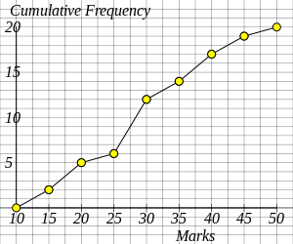  How many students scored more than 30 marks? | [1]
7) The cumulative frequency polygon below shows the number of minutes that 20 students used a telephone in one day.  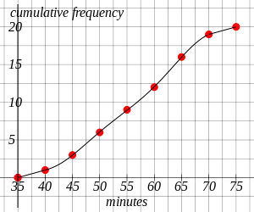  Estimate, using the graph, the median minutes of use?  (Give your answer to the nearest integer) | [1]
8) The cumulative frequency polygon below shows the number of minutes that 20 students used a laptop in one day.  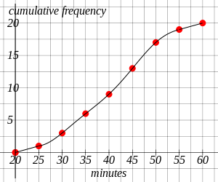  Estimate, using the graph, the lower quartile of the minutes of use?  (Give your answer to the nearest integer) | [1]
9) The cumulative frequency polygon below shows the number of minutes that 20 girls used a computer in one day.  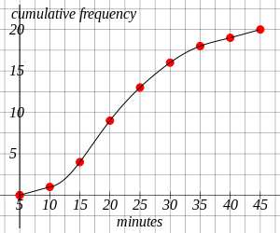  Estimate, using the graph, the upper quartile of the minutes of use?  (Give your answer to the nearest integer) | [1]
10) The cumulative frequency polygon below shows the number of minutes that 20 boys used a laptop in one day.  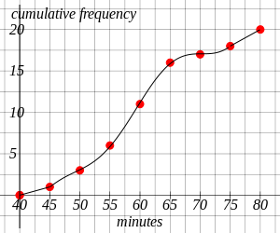  Estimate, using the graph, the interquartile range of the minutes of use?  (Give your answer to the nearest integer) | [1]
11) Using the table, complete the cumulative frequency graph showing the heights of 20 waterfalls, measured in metres.  Height of waterfalls Cumulative Frequency  h $≤$ 30 1  h $≤$ 35 3  h $≤$ 40 5  h $≤$ 45 7  h $≤$ 50 10  h $≤$ 55 15  h $≤$ 60 18  h $≤$ 65 20 | [1]
12) Complete the table and the cumulative frequency graph showing the heights of 20 fountains, measured in metres.  Height of fountains Frequency Cumulative Frequency  20 $≤$ h $<$ 25 1  25 $≤$ h $<$ 30 1  30 $≤$ h $<$ 35 3  35 $≤$ h $<$ 40 5  40 $≤$ h $<$ 45 5  45 $≤$ h $<$ 50 3  50 $≤$ h $<$ 55 1  55 $≤$ h $<$ 60 1 | [1]
13) The cumulative frequency table below shows the number of minutes that 20 boys used a mobile phone in one day. Using the table complete the cumulative frequency graph and use your graph to estimate the median minutes of use (to the nearest integer).  Minutes Cumulative Frequency  20 $≤$ x $<$ 25 1  20 $≤$ x $<$ 30 3  20 $≤$ x $<$ 35 6  20 $≤$ x $<$ 40 9  20 $≤$ x $<$ 45 13  20 $≤$ x $<$ 50 17  20 $≤$ x $<$ 55 19  20 $≤$ x $<$ 60 20 | [1]
14) The cumulative frequency table below shows the number of minutes that 20 people used a mobile phone in one day. Using the table complete the cumulative frequency graph and use your graph to estimate the interquartile range (to the nearest integer).  Minutes Cumulative Frequency  10 $≤$ x $<$ 15 1  10 $≤$ x $<$ 20 4  10 $≤$ x $<$ 25 5  10 $≤$ x $<$ 30 6  10 $≤$ x $<$ 35 11  10 $≤$ x $<$ 40 15  10 $≤$ x $<$ 45 17  10 $≤$ x $<$ 50 20 | [1]
Solutions for the assessment Cumulative Frequency
1) 19 | 2) The missing value is 14.
3) 5 | 4) 14
5) 12 | 6) 8
7) 57 minutes | 8) 34 minutes
9) 28 minutes | 10) 10 minutes
11)
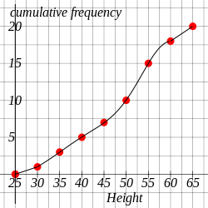

12) Cumulative Frequencies are 1, 2, 5, 10, 15, 18, 19, 20.
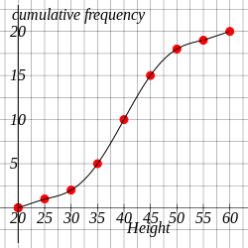

13) Median = 42 minutes
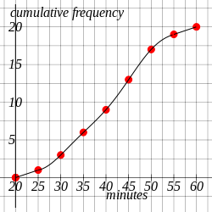

14) IQR = 15 minutes
