Cumulative Frequency
Name : | Class : | Date :

Mark : | /14 | %

1) Based on the frequency distribution below, find the cumulative frequency for the class with lower class limit 27  Ages 15 - 18 19 - 22 23 - 26 27 - 30 31 - 34 35 - 38  No. of Students 8 3 2 8 8 10 | [1]
2) 120 students took a test. The scores are summarized in the tables below.  Fill in the missing value in the frequency table.  Score Frequency 160 - 164 14 165 - 169 20 170 - 174 18 175 - 179 180 - 184 17 185 - 189 31 Score Cumulative Freq less than 165 14 less than 170 34 less than 175 52 less than 180 72 less than 185 89 less than 190 120 | [1]
3) The cumulative frequency polygon below shows the height of 20 fountains, measured in metres.  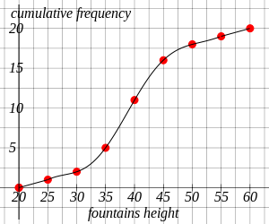  How many fountains were less than 35 metres tall? | [1]
4) The cumulative frequency polygon below shows the height of 20 trees, measured in metres.  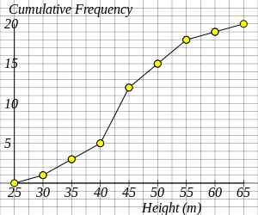  How many trees were greater than 45 metres tall? | [1]
5) The cumulative frequency polygon below shows the scores of 20 students in a business studies test.  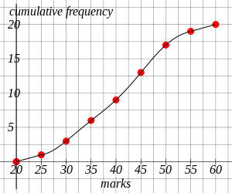  Estimate, using the graph, the number of students scoring less than 43?  (Give your answer to the nearest integer) | [1]
6) The cumulative frequency polygon below shows the scores of 20 students in a science test.  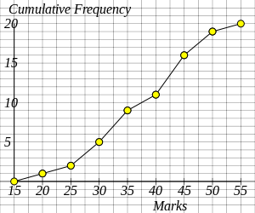  How many students scored more than 35 marks? | [1]
7) The cumulative frequency polygon below shows the number of minutes that 20 men used a telephone in one day.  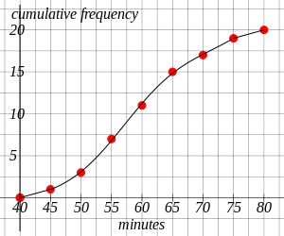  Estimate, using the graph, the median minutes of use?  (Give your answer to the nearest integer) | [1]
8) The cumulative frequency polygon below shows the number of minutes that 20 children used a mobile phone in one day.  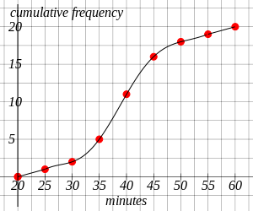  Estimate, using the graph, the lower quartile of the minutes of use?  (Give your answer to the nearest integer) | [1]
9) The cumulative frequency polygon below shows the number of minutes that 20 women used a computer in one day.  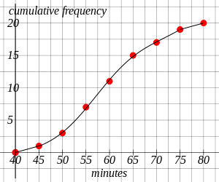  Estimate, using the graph, the upper quartile of the minutes of use?  (Give your answer to the nearest integer) | [1]
10) The cumulative frequency polygon below shows the number of minutes that 20 girls used a website in one day.  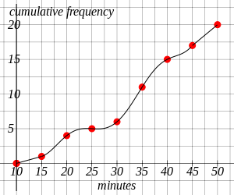  Estimate, using the graph, the interquartile range of the minutes of use?  (Give your answer to the nearest integer) | [1]
11) Using the table, complete the cumulative frequency graph showing the heights of 20 buildings, measured in metres.  Height of buildings Cumulative Frequency  h $≤$ 45 1  h $≤$ 50 3  h $≤$ 55 7  h $≤$ 60 11  h $≤$ 65 15  h $≤$ 70 17  h $≤$ 75 19  h $≤$ 80 20 | [1]
12) Complete the table and the cumulative frequency graph showing the heights of 20 fountains, measured in metres.  Height of fountains Frequency Cumulative Frequency  40 $≤$ h $<$ 45 1  45 $≤$ h $<$ 50 2  50 $≤$ h $<$ 55 2  55 $≤$ h $<$ 60 2  60 $≤$ h $<$ 65 4  65 $≤$ h $<$ 70 5  70 $≤$ h $<$ 75 2  75 $≤$ h $<$ 80 2 | [1]
13) The cumulative frequency table below shows the number of minutes that 20 children used a mobile phone in one day. Using the table complete the cumulative frequency graph and use your graph to estimate the median minutes of use (to the nearest integer).  Minutes Cumulative Frequency  20 $≤$ x $<$ 25 1  20 $≤$ x $<$ 30 2  20 $≤$ x $<$ 35 5  20 $≤$ x $<$ 40 10  20 $≤$ x $<$ 45 15  20 $≤$ x $<$ 50 18  20 $≤$ x $<$ 55 19  20 $≤$ x $<$ 60 20 | [1]
14) The cumulative frequency table below shows the number of minutes that 20 children used a mobile phone in one day. Using the table complete the cumulative frequency graph and use your graph to estimate the interquartile range (to the nearest integer).  Minutes Cumulative Frequency  40 $≤$ x $<$ 45 1  40 $≤$ x $<$ 50 3  40 $≤$ x $<$ 55 7  40 $≤$ x $<$ 60 11  40 $≤$ x $<$ 65 15  40 $≤$ x $<$ 70 17  40 $≤$ x $<$ 75 19  40 $≤$ x $<$ 80 20 | [1]
Solutions for the assessment Cumulative Frequency
1) 21 | 2) The missing value is 20.
3) 5 | 4) 8
5) 11 | 6) 11
7) 59 minutes | 8) 35 minutes
9) 65 minutes | 10) 15 minutes
11)
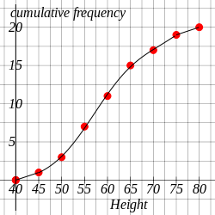

12) Cumulative Frequencies are 1, 3, 5, 7, 11, 16, 18, 20.
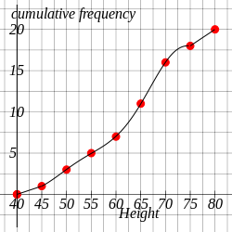

13) Median = 40 minutes
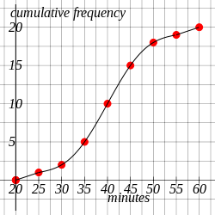

14) IQR = 12 minutes
