Pie Charts
Name : | Class : | Date :

Mark : | /7 | %

1) The pie chart shown below shows favourite colours of a group of people.  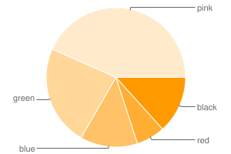  Find the total number of people in the survey, given that 7 people prefer green | [1]
2) The pie chart shown below shows favourite colours of 30 people.  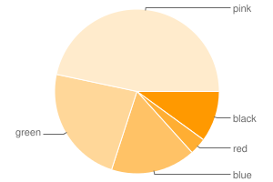  Find the number of people that prefer red | [1]
3) The pie chart below shows how students travel to school (angles are given in brackets).  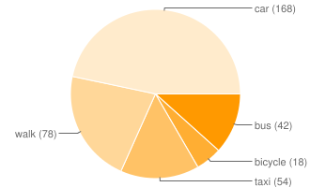  a) What is the most common method of travel?  b) What fraction of the students travel to school by bus?  c) If 7 students travel by bus, how many people took part in the survey? | [1]
4) The pie chart below shows how students travel to school.  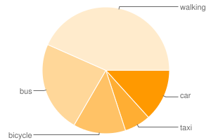  a) What is the most common method of travel?  b) What is the angle for students who travel by taxi?  c) What fraction of the students travel to school by car?  d) If 4 students travel by car, how many people took part in the survey? | [1]
5) The table below shows the favourite colours of 30 people. Complete the table to show the angles that would need to be calculated to construct a pie chart.  Colour black red blue green pink  Frequency 3 2 3 6 16  Angle | [1]
6) The table below shows the favourite colours of 60 people. Calculate the angle for each colour and construct a pie chart.  Colour blue black red pink green  Frequency 6 4 3 15 32  Angle  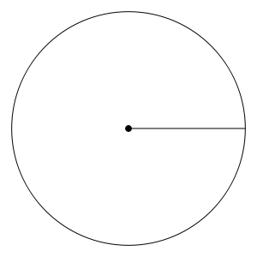 | [1]
7) The table below shows the favourite car brands of 30 people. Calculate the angle for each colour and construct a pie chart.  Colour Toyota Honda Ford VW BMW  Frequency 5 1 3 7 14  Angle  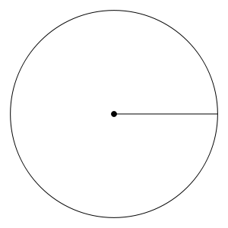 | [1]
Solutions for the assessment Pie Charts
1) 30 | 2) 1
3) a) car, b) 7/60, c) 60 | 4) a) walking, b) 24 °, c) 2/15, d) 30
5) black = 36 °, red = 24 °  blue = 36 °, green = 72 °, pink = 192 ° | 6) blue = 36 °, black = 24 °  red = 18 °, pink = 90 °, green = 192 °  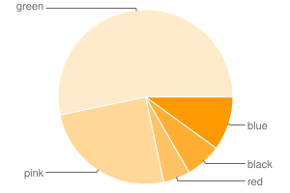
7) Toyota = 60 °, Honda = 12 °
Ford = 36 °, VW = 84 °, BMW = 168 °
