Pie Charts
Name : | Class : | Date :

Mark : | /7 | %

1) The pie chart shown below shows favourite colours of a group of people.  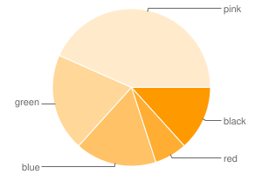  Find the total number of people in the survey, given that 5 people prefer blue | [1]
2) The pie chart shown below shows favourite colours of 60 people.  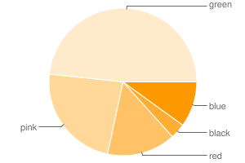  Find the number of people that prefer black | [1]
3) The pie chart below shows how students travel to school (angles are given in brackets).  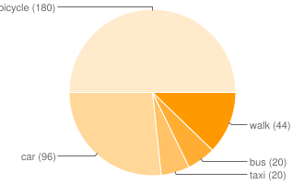  a) What is the most common method of travel?  b) What fraction of the students travel to school by walk?  c) If 11 students travel by walk, how many people took part in the survey? | [1]
4) The pie chart below shows how students travel to school.  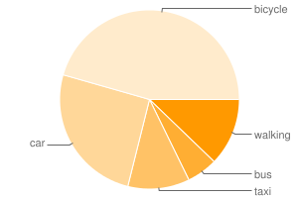  a) What is the most common method of travel?  b) What is the angle for students who travel by walking?  c) What fraction of the students travel to school by walking?  d) If 11 students travel by walking, how many people took part in the survey? | [1]
5) The table below shows the favourite colours of 90 people. Complete the table to show the angles that would need to be calculated to construct a pie chart.  Colour green pink black blue red  Frequency 12 3 12 23 40  Angle | [1]
6) The table below shows the favourite colours of 90 people. Calculate the angle for each colour and construct a pie chart.  Colour green pink black blue red  Frequency 10 4 14 22 40  Angle  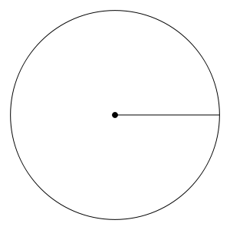 | [1]
7) The table below shows the favourite car brands of 30 people. Calculate the angle for each colour and construct a pie chart.  Colour Toyota Honda Ford VW BMW  Frequency 3 1 5 7 14  Angle  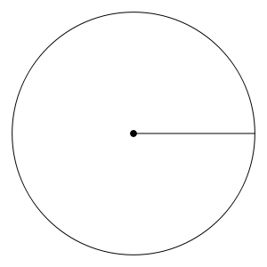 | [1]
Solutions for the assessment Pie Charts
1) 30 | 2) 2
3) a) bicycle, b) 11/90, c) 90 | 4) a) bicycle, b) 44 °, c) 11/90, d) 90
5) green = 48 °, pink = 12 °  black = 48 °, blue = 92 °, red = 160 ° | 6) green = 40 °, pink = 16 °  black = 56 °, blue = 88 °, red = 160 °  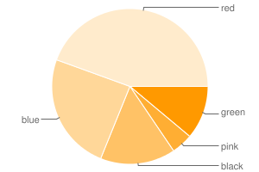
7) Toyota = 36 °, Honda = 12 °
Ford = 60 °, VW = 84 °, BMW = 168 °
