Questionnaires
Name : | Class : | Date :

Mark : | /6 | %

1) Caleb wants to find out what types of food people like best using the categories of Thai, Italian, Indian and Chinese.  a) Design a suitable table for a data collection sheet he could use to collect this information.  Caleb collects his data by asking 9 people at the cinema.  b) Give one reason why this might not be a good way to find out which food people like best. | [1]
2) Katie wants to find out how much time people spend on social media.  She is going to use a questionnaire.  Design a suitable question for Katie to use in her questionnaire.  You must include some response boxes. | [1]
3) Maisie wants to find out how much time people spend walking.  She is going to use this question for her questionnaire:  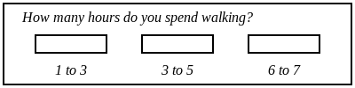  Write down two things that are wrong in this question.  Design a more suitable question for Maisie to use in her questionnaire. | [1]
4) Aidan wants to find out how often people go to the cinema.  He is going to use this question for her questionnaire:  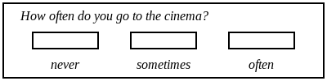  Write down two things that are wrong in this question.  Design a more suitable question for Aidan to use in his questionnaire. | [1]
5) The manager of a hotel has made some changes and wants to find out what people think of the changes.  He is going to use this question for his questionnaire:  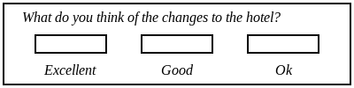  Write down what is wrong with this question.  Design a more suitable question for the manager to use in his questionnaire. | [1]
6) The manager of a pub has made some changes and wants to find out what people think of the changes.  She is going to use this question for her questionnaire:  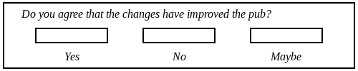  Write down what is wrong with this question.  Design a more suitable question for the manager to use in her questionnaire. | [1]
Solutions for the assessment Questionnaires
1) a) Any suitable table that has columns for tally or frequency or both.  b) Sample size not large enough. Sample might not represent population because it's only in one location. Biased sample. | 2)
3) ~ | 4) ~
5) ~ | 6) ~

