Questionnaires
Name : | Class : | Date :

Mark : | /6 | %

1) Joshua wants to find out what types of food people like best using the categories of Thai, French, Indian and British.  a) Design a suitable table for a data collection sheet he could use to collect this information.  Joshua collects his data by asking 9 people outside a supermarket.  b) Give one reason why this might not be a good way to find out which food people like best. | [1]
2) Elisabeth wants to find out how much time people spend driving to work.  She is going to use a questionnaire.  Design a suitable question for Elisabeth to use in her questionnaire.  You must include some response boxes. | [1]
3) Megan wants to find out how much time people spend on their computer.  She is going to use this question for her questionnaire:  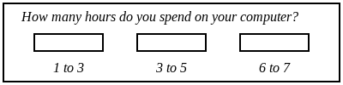  Write down two things that are wrong in this question.  Design a more suitable question for Megan to use in her questionnaire. | [1]
4) Elijah wants to find out how often people go to the cinema.  He is going to use this question for her questionnaire:  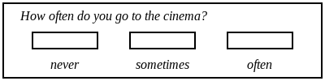  Write down two things that are wrong in this question.  Design a more suitable question for Elijah to use in his questionnaire. | [1]
5) The manager of a shop has made some changes and wants to find out what people think of the changes.  She is going to use this question for her questionnaire:  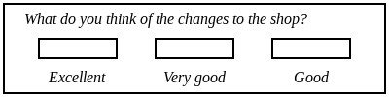  Write down what is wrong with this question.  Design a more suitable question for the manager to use in her questionnaire. | [1]
6) The manager of a swimming pool has made some changes and wants to find out what people think of the changes.  He is going to use this question for his questionnaire:  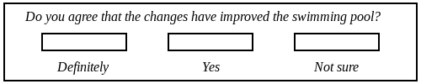  Write down what is wrong with this question.  Design a more suitable question for the manager to use in his questionnaire. | [1]
Solutions for the assessment Questionnaires
1) a) Any suitable table that has columns for tally or frequency or both.  b) Sample size not large enough. Sample might not represent population because it's only in one location. Biased sample. | 2)
3) ~ | 4) ~
5) ~ | 6) ~

