Questionnaires
Name : | Class : | Date :

Mark : | /6 | %

1) Archie wants to find out what types of films people like best using the categories of Suspense, Thriller, Animated and Romance.  a) Design a suitable table for a data collection sheet he could use to collect this information.  Archie collects his data by asking 11 people outside a supermarket.  b) Give one reason why this might not be a good way to find out which films people like best. | [1]
2) Harriet wants to find out how much time people spend on the internet.  She is going to use a questionnaire.  Design a suitable question for Harriet to use in her questionnaire.  You must include some response boxes. | [1]
3) Hannah wants to find out how much time people spend stuck in traffic.  She is going to use this question for her questionnaire:  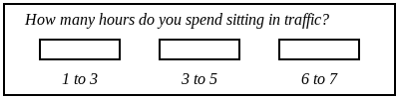  Write down two things that are wrong in this question.  Design a more suitable question for Hannah to use in her questionnaire. | [1]
4) Adam wants to find out how often people visit their grandparents.  He is going to use this question for her questionnaire:  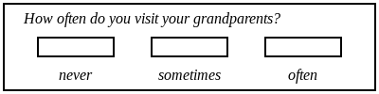  Write down two things that are wrong in this question.  Design a more suitable question for Adam to use in his questionnaire. | [1]
5) The manager of a restaurant has made some changes and wants to find out what people think of the changes.  She is going to use this question for her questionnaire:  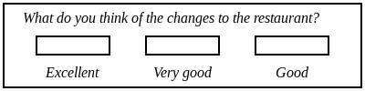  Write down what is wrong with this question.  Design a more suitable question for the manager to use in her questionnaire. | [1]
6) The manager of a pub has made some changes and wants to find out what people think of the changes.  He is going to use this question for his questionnaire:  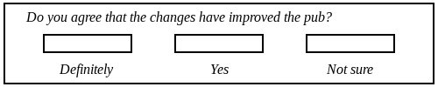  Write down what is wrong with this question.  Design a more suitable question for the manager to use in his questionnaire. | [1]
Solutions for the assessment Questionnaires
1) a) Any suitable table that has columns for tally or frequency or both.  b) Sample size not large enough. Sample might not represent population because it's only in one location. Biased sample. | 2)
3) ~ | 4) ~
5) ~ | 6) ~

