Congruent Shapes - advanced
Name : | Class : | Date :

Mark : | /8 | %

1) Write down the letters of a pair of congruent shapes from the grid below  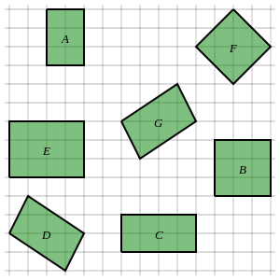 | [1]
2) Identify all pairs of congruent shapes in the grid below  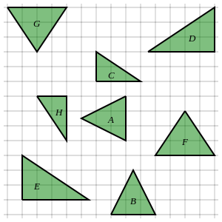 | [1]
3) Identify the only shape which is not congruent to any other shape in the grid below  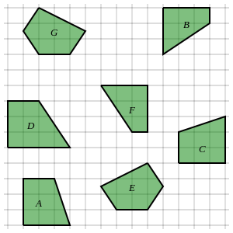 | [1]
4) Identify all pairs of congruent triangles. Note that the diagram is not drawn to scale.  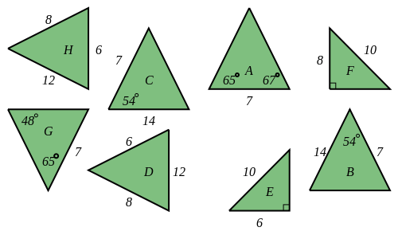 | [1]
5) Identify the only pair of congruent triangles which can be proved using the '3 equal sides' rule (SSS)  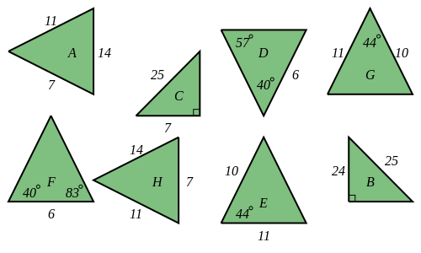 | [1]
6) Identify the only pair of congruent triangles which can be proved using the '2 angles and a corresponding side' rule (AAS)  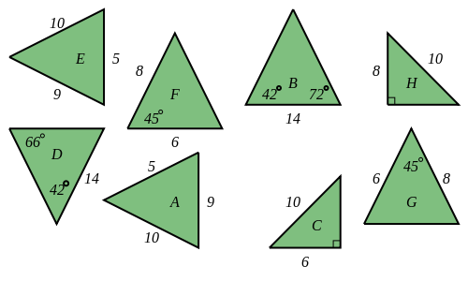 | [1]
7) Identify the only pair of congruent triangles which can be proved using the '2 sides and the included angle' rule (SAS)  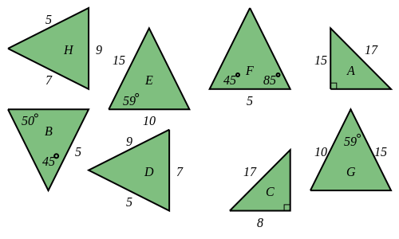 | [1]
8) Identify the only pair of congruent triangles which can be proved using the 'right angle, hypotenuse and side' rule (RHS)  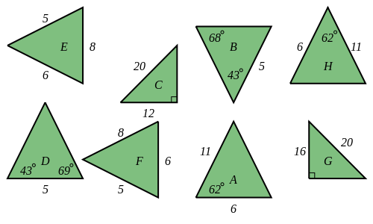 | [1]
Solutions for the assessment Congruent Shapes - advanced
1) D and G | 2) B and A, H and C, G and F, D and E
3) D | 4) B and C, H and D, G and A, F and E
5) A and H | 6) D and B
7) G and E | 8) G and C

