Congruent Shapes
Name : | Class : | Date :

Mark : | /4 | %

1) Write down the letters of a pair of congruent shapes from the grid below  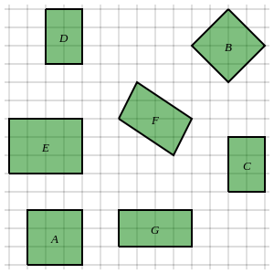 | [1]
2) Identify all pairs of congruent shapes in the grid below  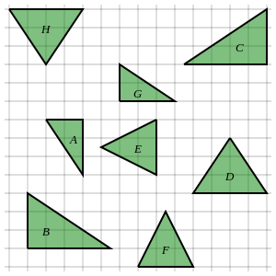 | [1]
3) Identify the only shape which is not congruent to any other shape in the grid below  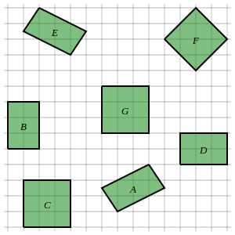 | [1]
4) Identify all pairs of congruent triangles. Note that the diagram is not drawn to scale.  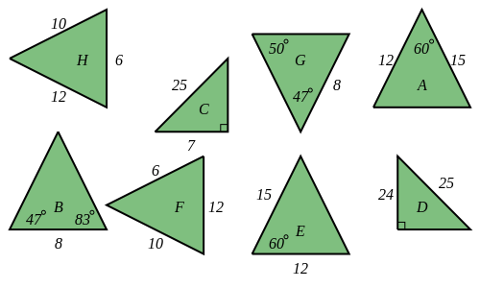 | [1]
Solutions for the assessment Congruent Shapes
1) D and C | 2) F and E, A and G, H and D, C and B
3) F | 4) A and E, H and F, G and B, D and C

