Areas and Volumes of similar shapes
Name : | Class : | Date :

Mark : | /12 | %

1) Triangle ABC is similar to triangle DEF. Find the length of the sides $x$ and $y$.  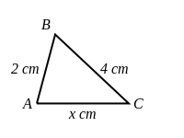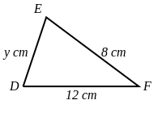 | [1]
2) Find the missing length, $x$, in rectangle ABCD shown below  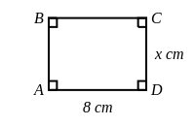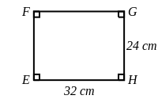 | [1]
3) Find the missing lengths, $x$ and $y$, in the picture below  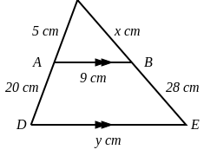 | [1]
4) The two circles, A and B, are mathematically similar.  The lengths in B are triple the lengths in A.  The area of A is 14 $cm^{2}$. Find the area of B.  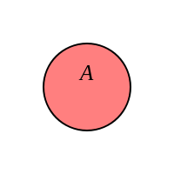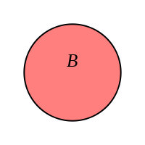 | [1]
5) The two rectangles, A and B, are mathematically similar.  The lengths in B are twice the lengths in A.  The area of B is 60 $cm^{2}$. Find the area of A.  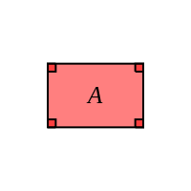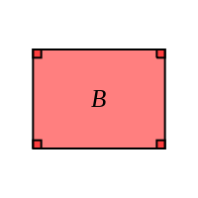 | [1]
6) The two circles, X and Y, are mathematically similar.  The areas of X and Y are 12 $cm^{2}$ and 192 $cm^{2}$, respectively.  The radius of X is 10 cm. Find the corresponding radius of Y. | [1]
7) The two circles, X and Y, are mathematically similar.  The areas of X and Y are 19 $cm^{2}$ and 171 $cm^{2}$, respectively.  The radius of Y is 27 cm. Find the corresponding radius of X. | [1]
8) Two cylinders, A and B, are mathematically similar.  The height of B is twice the corresponding height of A.  The surface area of A is 14 $cm^{2}$. Find the surface area of B.  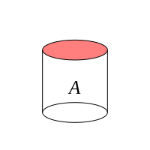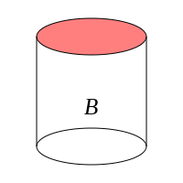 | [1]
9) Two spheres, A and B, are mathematically similar.  The radius of B is triple the corresponding radius of A.  The volume of A is 20 $cm^{3}$. Find the volume of B.  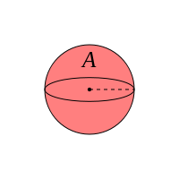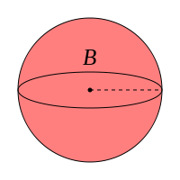 | [1]
10) Two cubes, A and B, are mathematically similar.  The height of B is triple the corresponding height of A.  The volume of B is 378 $cm^{3}$. Find the volume of A.  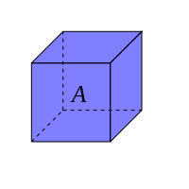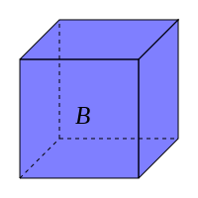 | [1]
11) Two cubes, A and B, are mathematically similar.  The volumes of A and B are 19 $cm^{3}$ and 152 $cm^{3}$, respectively.  The height of A is 7 cm. Find the corresponding height of B. | [1]
12) Two cylinders, A and B, are mathematically similar.  The volumes of A and B are 12 $cm^{3}$ and 96 $cm^{3}$, respectively.  The height of B is 18 cm. Find the corresponding height of A. | [1]
Solutions for the assessment Areas and Volumes of similar shapes
1) $x$ = 6 cm, $y$ = 4 cm | 2) $x$ = 6 cm
3) $x$ = 7 cm and $y$ = 45 cm | 4) Area = 126 $cm^{2}$
5) Area = 15 $cm^{2}$ | 6) radius of Y = 40 cm
7) radius of X = 9 cm | 8) Surface area of B = 56 $cm^{2}$
9) Volume of B = 540 $cm^{3}$ | 10) Volume of A = 14 $cm^{3}$
11) height of B = 14 cm | 12) height of A = 9 cm

