Similar Shapes
Name : | Class : | Date :

Mark : | /8 | %

1) The two rectangles shown below are similar.  The sides of Rectangle EFGH are three times as big as rectangle ABCD. Find the length and width of rectangle EFGH.  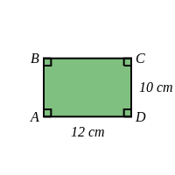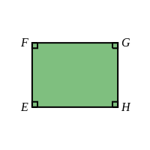  Length = ..... cm Width = ..... cm | [1]
2) The two rectangles shown below are similar.  The sides of Rectangle EFGH are three times as big as rectangle ABCD. Find the length and width of rectangle ABCD.  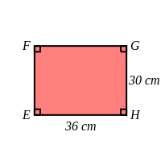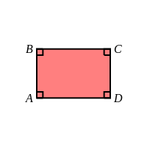  Length = ..... cm Width = ..... cm | [1]
3) The two rectangles shown below are similar.  Find the missing length, $x$, in rectangle ABCD.  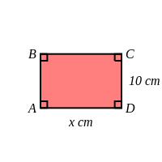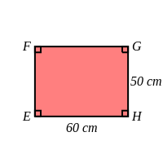  $x$ = ..... cm | [1]
4) The two rectangles shown below are similar.  Find the missing length, $x$, in rectangle EFGH.  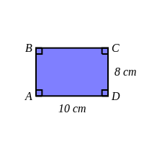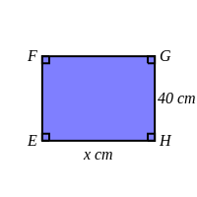  $x$ = ..... cm | [1]
5) The two triangles shown below are similar.  Find the missing length, $x$, in triangle ABC.  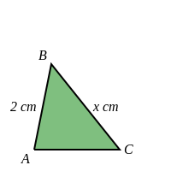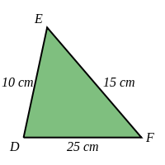  ..... | [1]
6) The two triangles shown below are similar.  Find the missing length, $x$, in triangle DEF.  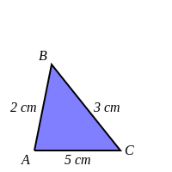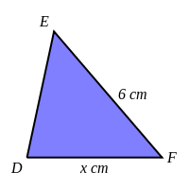  ..... | [1]
7) Triangle ABC is similar to triangle DEF.  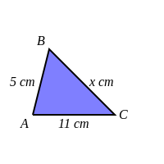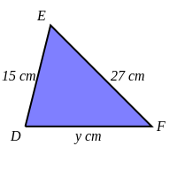  Find a) $x$ ..... b) $y$ ..... | [1]
8) Triangle ABC is similar to triangle DEF.  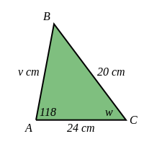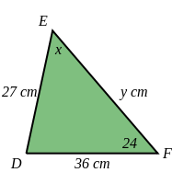  Find a) $v$ ..... b) $w$ ..... c) $x$ ..... d) $y$ ..... | [1]
Solutions for the assessment Similar Shapes
1) Length = 36 cm, Width = 30 cm, | 2) Length = 12 cm, Width = 10 cm,
3) $x$ = 12 cm | 4) $x$ = 50 cm
5) $x$ = 3 cm | 6) $x$ = 10 cm
7) $x$ = 9 cm, $y$ = 33 cm | 8) $v$ = 18 cm, $w$ = 24 °, $x$ = 38 °, $y$ = 30 cm

