Basic Similar Triangles
Name : | Class : | Date :

Mark : | /10 | %

1) Find the missing length, $x$, in triangle ABC below  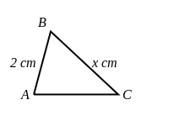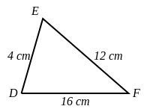 | [1]
2) Find the missing length, $x$, in triangle ABC below  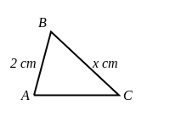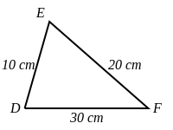 | [1]
3) Find the missing length, $x$, in triangle ABC below  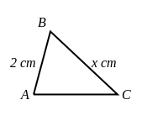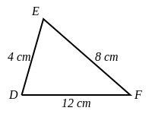 | [1]
4) Find the missing length, $x$, in triangle DEF below.  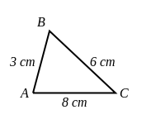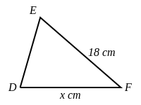 | [1]
5) Find the missing length, $x$, in triangle DEF below.  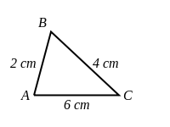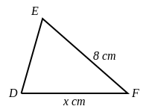 | [1]
6) Find the missing length, $x$, in triangle DEF below.  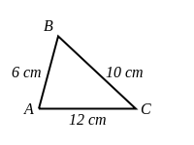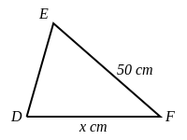 | [1]
7) Triangle ABC is similar to triangle DEF. Find the length of the sides $x$ and $y$.  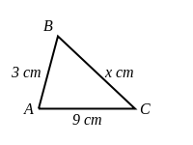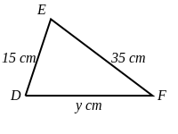 | [1]
8) Triangle ABC is similar to triangle DEF. Find the length of the sides $x$ and $y$.  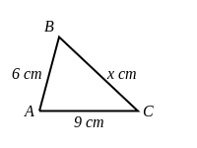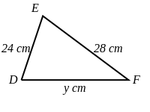 | [1]
9) Triangle ABC is similar to triangle DEF. Find the length of the sides $x$ and $y$.  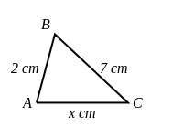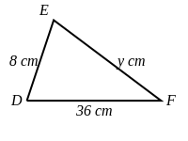 | [1]
10) Triangle ABC is similar to triangle DEF. Find the unknown sides and angles.  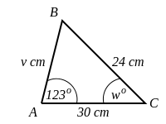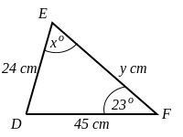 | [1]
Solutions for the assessment Basic Similar Triangles
1) $x$ = 6 cm | 2) $x$ = 4 cm
3) $x$ = 4 cm | 4) $x$ = 24 cm
5) $x$ = 12 cm | 6) $x$ = 60 cm
7) $x$ = 7 cm, $y$ = 45 cm | 8) $x$ = 7 cm, $y$ = 36 cm
9) $x$ = 9 cm, $y$ = 28 cm | 10) $v$ = 16 cm, $w$ = 23 °, $x$ = 34 °, $y$ = 36 cm

