Sine Rule, Cosine Rule and Area Rule
Name : | Class : | Date :

Mark : | /13 | %

1) Find the value of $x$ in the triangle below, giving your answer to 3 significant figures.  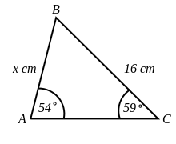 | [1]
2) Find $x$ in the triangle below, giving your answer to 3 significant figures.  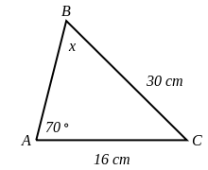 | [1]
3) Find $x$ in the triangle below, giving your answer to 3 significant figures.  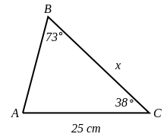 | [1]
4) Find $x$ in the triangle below, rounding your answer to 1 decimal place.  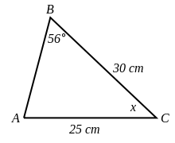 | [1]
5) Find the size of angle $x$, giving your answer to 1 decimal place.  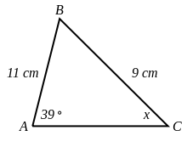 | [1]
6) The path of a satellite orbiting the earth causes it to pass directly over two tracking stations A and B, which are 74 km apart. When the satellite is on one side of the two stations, the angles of elevation at A and B are measured to be 86.3 ° and 85.1 °, respectively.  Find how far the satellite is from station A and how high the satellite is above the ground. Round your answers to 2 decimal places. | [1]
7) Find $x$ in the triangle below, giving your answer to 3 significant figures.  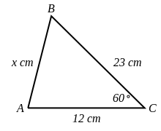 | [1]
8) Find the value of $x$ in the triangle below, giving your answer to 3 significant figures.  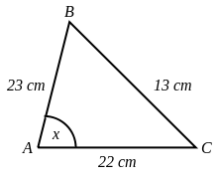 | [1]
9) Points A and B are separated by a building. To find the distance between them, a surveyor locates a point C such that angle CAB =51.3 °.  The distance AC = 335 m and BC = 479 m.  Find the distance from A to B, giving your answer to 3 significant figures. | [1]
10) Find the area of the triangle below, giving your answer to 3 significant figures.  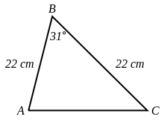 | [1]
11) The area of triangle ABC is 190 cm². Find the length of $x$, giving your answer to 3 significant figures.  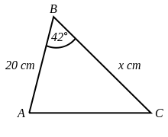 | [1]
12) The area of triangle ABC is 180 $cm^{2}$. Find the size of angle $x$, giving your answer to 3 significant figures.  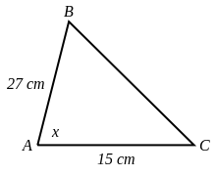 | [1]
13) The area of triangle ABC is 112 $cm^{2}$.  Find the perimeter of triangle ABC, giving your answer to 3 significant figures.  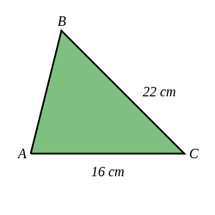 | [1]
Solutions for the assessment Sine Rule, Cosine Rule and Area Rule
1) $x$ = 17.0 cm | 2) $x$ = 30.1 °
3) $x$ = 24.4 cm | 4) $x$ = 39.8 °
5) acute angle $x$ = 50.3 °, obtuse angle $x$ = 129.7 ° | 6) Distance = 3520.58 km, Height = 3513.24 km
7) $x$ = 19.9 cm | 8) $x$ = 33.5 °
9) Distance = 376 m | 10) Area = 125 $cm^{2}$
11) $x$ = 28.4 cm | 12) $x$ = 62.7 °
13) Perimeter = 52.0 cm

