Sine Rule, Cosine Rule and Area Rule
Name : | Class : | Date :

Mark : | /13 | %

1) Find the value of $x$ in the triangle below, giving your answer to 3 significant figures.  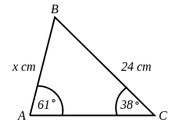 | [1]
2) Find $x$ in the triangle below, giving your answer to 3 significant figures.  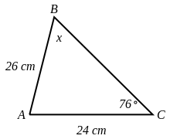 | [1]
3) Find $x$ in the triangle below, giving your answer to 3 significant figures.  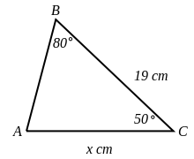 | [1]
4) Find $x$ in the triangle below, rounding your answer to 1 decimal place.  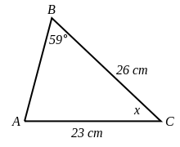 | [1]
5) Find the size of angle $x$, giving your answer to 1 decimal place.  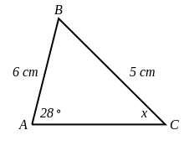 | [1]
6) The path of a satellite orbiting the earth causes it to pass directly over two tracking stations A and B, which are 60 km apart. When the satellite is on one side of the two stations, the angles of elevation at A and B are measured to be 86.4 ° and 85 °, respectively.  Find how far the satellite is from station A and how high the satellite is above the ground. Round your answers to 2 decimal places. | [1]
7) Find $x$ in the triangle below, giving your answer to 3 significant figures.  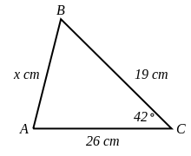 | [1]
8) Find the value of $x$ in the triangle below, giving your answer to 3 significant figures.  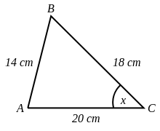 | [1]
9) Points A and B are separated by a building. To find the distance between them, a surveyor locates a point C such that angle CAB =42.9 °.  The distance AC = 400 m and BC = 471 m.  Find the distance from A to B, giving your answer to 3 significant figures. | [1]
10) Find the area of the triangle below, giving your answer to 3 significant figures.  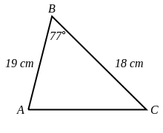 | [1]
11) The area of triangle ABC is 140 cm². Find the length of $x$, giving your answer to 3 significant figures.  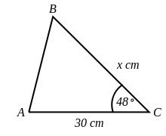 | [1]
12) The area of triangle ABC is 280 $cm^{2}$. Find the size of angle $x$, giving your answer to 3 significant figures.  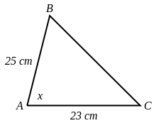 | [1]
13) The area of triangle ABC is 109 $cm^{2}$.  Find the perimeter of triangle ABC, giving your answer to 3 significant figures.  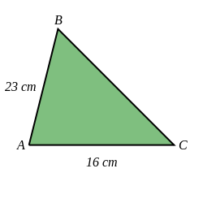 | [1]
Solutions for the assessment Sine Rule, Cosine Rule and Area Rule
1) $x$ = 16.9 cm | 2) $x$ = 63.6 °
3) $x$ = 24.4 cm | 4) $x$ = 45.3 °
5) acute angle $x$ = 34.3 °, obtuse angle $x$ = 145.7 ° | 6) Distance = 2446.43 km, Height = 2441.6 km
7) $x$ = 17.4 cm | 8) $x$ = 42.8 °
9) Distance = 325 m | 10) Area = 167 $cm^{2}$
11) $x$ = 12.6 cm | 12) $x$ = 76.9 °
13) Perimeter = 52.9 cm

